**A**

PROJECT-REPORT **ON**

**ONLINE ASSIGNMENT SUBBMISSION**

**Submitted in Partial Fulfilment of requirement for the degree**

**For**

**BACHELOR OF TECHNOLOGY**

**In**

**(Computer Science and Engineering)**

**Submitted by**

**PAVAN KUMAR- 1542510026**

**NITIN SHARMA- 1542510023**

**FIROZ-1542510007**

**UNDER THE GUIDANCE OF**

**Mr. RAHUL SHARMA**

Dept. of Computer Science and Engineering

**MEERUT INTERNATIONAL INSTITUTE OF TECHNOLOGY, MEERUT**



**CERTIFICATE**

This is to certify that project that dissertation/project report entitled “ONLINE ASSIGNMENT SUBMISSION” done by PAVAN KUMAR,NITIN SHARMA,FIROZ is an authentic work carried out by him at Limited under my guidance. The matter inputted in this project work has not been submitted earlier for the award of any degree or diploma to best of my knowledge and belief.

DATE-

NAME- **MR**. **RAHUL** **SHARMA**

**SIGNARURE……………………………… (C.S.E DEPTT)**

**ACKNOWLEDGMENT**

I would like to thanks Mr. Rahul Sharma for giving me such a wonderful opportunity to expand my knowledge for my own branch and giving me guidelines to present a online assignment submission report. it helped me a lot to realize of what we study for.

Secondly, I would like to thank my parents who patiently helped me as I went through my work and helped to modify and eliminate some of the irrelevant or un-necessary stuff.

Thirdly, I would lick to thank my friends who helped me to make my work more organized and well-stacked till the end.

Next, I would thank Microsoft for developing such a wonderful tool like MS Word.it help my work a lot to remain error-free. Last but clearly not the least, I would think The Almighty for giving me strength to complete my report on time.

**PREFACE**

I have made this report file on the topic **Online Assignment Submission;** I have tried my best to elucidate all the relevant detail to the topic to be included in the report. while in the beginning I have tried to give a general view about this topic.

My efforts and wholehearted co-corporation of each and everyone has ended on a successful note. I express my sincere gratitude to Mr. Rahul Sharma who assisting me throughout the preparation of this topic. I thank him for providing me the reinforcement, confidence and most importantly the track for the topic whenever needed it.

**CONTENTS**

PAGE NO.

|  |  |  |
| --- | --- | --- |
| **CHAPTER 1** | INTERODUCTION | 7 |
| **CHAPTER 2** | OBJECTIVE | 8 |
| **CHAPTER 3** | TOOLS/ENVIRONMENT USED | 9 |
| **CHAPTER 4** | ANALYSIS DOCUMENT | 15 |
| **CHAPTER 5** | SRS | 21 |
|  | * DATA FLOW DIAGRAM | 27 |
| **CHAPTER 6** | PROGRAM CODE | 33 |
| **CHAPTER 7** | TESTING | 80 |
| **CHAPTER 8** | INPUT AND OUTPUT SCENES |  |
| **CHAPTER 9** | IMPLEMENTATION OF SECURITY FOR THE SOFTEARE DEVELOPED |  |
| **CHAPTER 10** | LIMITATION OF THE PROJECT |  |
| **CHAPTER 11** | SCOPE OF THE PROJECT |  |
| **CHAPTER 12** | BIBLIOGRAPHY |  |
|  |  |  |

**ABSTRACT**

Online assignment are an important method of evaluating the personality of Student. This research effort the individuals under consideration were Student who would be enrolling in computer course . A prototype of a web-based placement assignment submission is described from the standpoint of the research effort, end user, and software development.

An on-line education system including exam processing and electronic journal features. An instructor builds a course based questions which on-line contain in identification in the on-line contain in identification of assignments. Which are compiled into an on-line exam syllabus?

User enrolled in the platform may access the electronic details they provided and perform various function with the on-line education system in order to participate in the on-line assignment. Users can receive an on-line assignment having multimedia content, for the course, and they can electronically provide question for the assignment. And after Completion of their duration of exam they are provided The grade or marks secured in their assignment.

**1. INTRODUCTION**

The Assignment Submission web application is a platform where the admin can login in this application then to create teachers and student id password to fill the details then student and teachers can login in the application teacher upload the question of the assignment on different on this web applications and another user(student) to give the answer and upload on different when teacher check the assignment and add details. student

The Assignment Submission application world software is totally user oriented and only users access the software programs. The user can assign multiple id password of the applications that re made with the help of java. Any particular IDE can be used for the development of the project. You can choose Eclipse, NetBeans according to your convenience. The front end tool required for this project is the J.S.P,HTML,C.S.S and java script, servlet and database of MySQL back end tools are being used. The user interface has been given a nice and trendy look with a professional feeling.

**1.1 PURPOSE:**

The purpose of the software development specification document is maintain all the functions and the specifications of E- TUTORIAL with an ONLINE ASSIGNMRNT .it contains the detailed description of the total functionality in the web portal. The purpose is to provide a web based questions which can conveniently enable users to learn in an easy manner. after the completion of the topic, the user can also give an tip answers and upload online

**2. Objective & Scope of the project**

The main objective of the project id to make Online Assignment Submission. The system should have a provision of the login page for admin login and then create the student and teacher id for login each. This process will make Secret Intelligence agency very easy . Person who is working we only give command to design is work this will reduce the humane effort and make the system fast.

**Other Objectives:**

* User friendly interface.
* A central database holds the key to system.
* All forms are html templates driven.
* Integration among all functional areas
* The availability of the information is easy.
* Routine take are easily performed.
* In summary we can say that main objective of the project is to make the work easy and smooth.
* It will provide the better customer service and enhance the profit or the organization.

**3. TOLLS AND ENVERONMENT USED**

**PROJECT CATEGORY:**

**3.1 JAVA SERVER PAGE (JSP):**

Java Server pages is a simple, yet powerful technology for creating and maintaining dynamic- content web pages. Based on the java programming language java server page offer proven probability, open standards, and a mature re- usable component model.

This JSP engine for a particular server might be built-in or might be provided though a 3rd party add-on as long as the server in which you plan to execute the java server pages supports the same specification level as that to which the file was writing, on change should be necessary as you move files from server to server. Note, however, that instructions for the setup and configuration of the files may between files.

3.2 **PROCESSING:**

The java server pages file has extension to identify in to the server as a java server pages file. Before the page is served page syntax is parsed and processed in to servlet on the server side .The servlet that generated, output real content in straight HTML for responding to the customer. Because than a static response.

In this scenario suppose the page accessed reusable java bean components that perform particular well-defined computations like accessing a database. The result of the bean’s computations called result sets is stored within the bean as properties. The page uses such beans to generate dynamic content and present back to the client. A request comes through a servlet:

**3.3 SERVLET:**

A servlet is a java programming language class used to extend the capabilities of servers that host applications accessed via a request- response programming model. Although servlets can respond to any type of request, they are commonly used to extend the applications hosted by Web servers. For such applications, java servlet technology defines HTTP-specific servlet classes.

The javax.servlet and javax.servlet.http packages provide interfaces and classes for writing servlets. All servlets must implement the servlet interface, which defines life-cycle methods.

The servlet generates the dynamic content. To handle the response to the client, the servlet creates a Bean and stores the dynamic content in the Bean. The servlet then invokes a java Sever page that will present the content along with the Bean containing the generated from the servlet.

There are two API is to support this model of request processing using Java Sarver Pages. One API facilitates passing context between the invoking servlet and the Java Server Page. The other API lets the invoking servlet and the java Server Page. The other API lets the invoking servlet specify which Java Server Page to use.

In both of the above cases, the page could also contain any valid Java code. The Java Server Pages architecture separation of content from presentation- -it does not mandate it.

JFBC requires that the SQL statements be passed as String to Java methods. For example, our application might present a menu of database tasks from which to choose. After a task is selected, the application presents prompt and blanks for filling information needed to carry out the selected task. With the requested input typed in, the application them automatically invokes the necessary commands.

In this project we have implemented three-tier model, commands are sent to a “middle tier “ of services which then send SQL statements to the database. The database process the SQL statements and sends the results back access from a Java middle tier.

**3.4 FRONT END**

1. **J2EE-** Java 2 Enterprise Edition is a programming platform part of Java Platform for developing and running multitier Java applications, based largely on modular software components running on an application server.
2. **TOMCAT** It’s an application server which is mostly used in the web applications. It implements the Servlet 2.5 & JSP 2.1 specifications. It’s a cross-platform application Server.
3. **JSP-** Java Server Pages is a server side Java technology that allows software developers to create dynamically generated web pages, with HTML, XML or other document type. JSPs are compiled into Servlets by JSP compiler.
4. **SERVLET -** Servlets are Java programming language object that dynamically process requests & construct responses. The Servlet APIs are contained in the javax.servlet & javax.servlet.http Packages. Servlets can be generated automatically by java server pages (JSP) compiler.
5. **NetBeans-** NetBeans is the most comprehensive J2EE IDE() for the open Source net beans platform .It incorporates most innovative open standard technologies to provide a development environment for J2EE WEB ,XML,UML & database & a wide array of application server connectors to streamline development , deployment ,testing & portability. It’s a cross-platform.
6. **Java Script--** JavaScript is a programing language that is used to make web pages interactive. It runs on your visitor’s computer and so does not require constant download from your web site.
7. **Ajax-** Ajax (sometimes called Asynchronous JavaScript and XML) is a way of programming for the Web that gets rid of the hourglass. Data, content, and design are merged together into a seamless whole. When your costumer clicks on something on an Ajax driven application, there is very lag time.
8. **Cascading Style Sheets (CSS) -** is a style sheet language used to describe the presentation semantics (the look and formatting ) of a document written in a markup language. Its most common application is to style web pages written in HTML and XHTML, but the language can also be applied to any kind of XML document, including SVG and XUL.

**3.5 What is JDBS:**

JDBC is a java API for executing SQL statements. (As a point of interest, JDBC is a trademarked name and is not an acronym; nevertheless JDBC is often thought of as standing for “ java Database Connectivity”.) It consists of a set of classes and interface written in the java programming language. JDBC provides a standard API for tool/database developers and makes it possible to write database application using a pure java API.

Using JDBC, it is easy to virtually any relational database. In other words, the JDBC API, It isn’t necessary to write one program to access a Sybase database, another program to access an Oracle database, another program to access an Informix database, and so on. One can write a single program using the JDBC API, and the program will be able to send SQL statements to the appropriate database. And whit an application written in the java programming to run on different platform. The combination of different database. JDBC is the mechanism for doing this.

JDBC extends what can be done in java. For example, whit java and the JDBC API, it is possible to publish a web page containing an applet that uses information obtained form a remote database. Or an enterprise can user JDBC to connect all its employees (ever if they are using conglomeration of windows, Macintosh, and UNIX machines) to one or more internal database via intranet. With ,ore and more programmers using the java programming language, the need easy database access form java is continuing to grow.

3.6 **Introduction To MySQL:**

Modern relation database management system can perform a wide range of tasks. It has got following advantages-

* Define a database
* Query the database
* Add, edit and delete data.
* Modify the structure of the database
* Secure database from public access.
* Communicate within networks
* Export and import data

MySQL is one such RDBMS. It provides a set of functional programs that we use a tool to build structure and performs tasks, in MySQL data is stored and displayed in table. A table is a data structure that holds data in a relationship database. A table comprises of rows and columns. Table can also show relationship between entities. The formal name of table is relation hence the name Relational Database Management System.

3.7 Access of Data in MySQL: SQL is a structured query language that we to communicate with MySQL. It consists of English words like Select etc. The standard set of SQL command fail into following category-

* Queries using select clause
* Data definition language (DLL) commands which are for creating and altering the structure of database.

3.8 Salient Features of MySQL:

* Open Source
* Efficient multi-user support and consistency
* Powerful security feature fault tolerance
* Ease of administration
* Application development tools
* Networking
* SQL compatibility

3.9 About SQL:

SQL is a structured query language that we use to communicate with consists of a set of English words like select, Create etc.

3.10 Tools / platform. Hardware and Software Requirement specification

HARDWARE SPECIFICATION

VIRTUAL MEMEORY :32 BIT. Pentium-IV

RAM : 1 GB

HARD DISK : 40 GB

MONITOR :SVGE Monitor (800 * 600RESOLUTIONS)

CLOCK SPEED : 266 MHz

SOFTWARE SPECIFICATION

OPERATING SYSTEM : windows 2000/XP.

FORNT END : JAVA (j2EE)

BACK END : My Sql

**4.SYSTEM ANALYSIS**

**4.8 Preliminary Investigation:**

The first step in the system development life cycle is preliminary investigation to determine the feasibility of the System. The purpose of the preliminary investigation is to evaluate project requests. It is neither a design study nor does it includes the collection of details top describe the business system in all respect. Rather, it is collecting of information that helps committee members of evaluate the merits of the project request and make an informed judgment about the feasibility of the proposed project.

Here for the “ONLINE ASSIGNMENT”, I have worked on the preliminary investigation that accomplished the following objectives:

* Clarify and understand the project request
* Determine the size of the project
* Assess costs and benefits of alternative approaches
* Determine the technical and operational feasibility of alternative approaches.

Report the findings to management with recommendation outlining the acceptances or

Rejection of the proposal.

Considering above criteria I also keep in mind that the requirements are clearly understandable when the clarification of project request is enquired. The data of the IT Companies which are collected by me during preliminary investigation are:-

* Reviewing organization Documents
* Onsite observation and
* Conducting interviews

4.9 **Feasibility Study:**

Not everything imaginable is feasible not even in software evanescent as it may appear to outsiders. Feasibility is the determination of whether or not a project is worth doing. On the contrary software feasibility has seven solid dimensions as below:-

1. Technical feasibility.
2. Operational feasibility.
3. Economic feasibility

The process followed in making the determination is called a feasibility study. This type of study determines when a project can or should be taken. Once it has been determined that the project requirements. Generally, feasibility studies are undertaken within tight time constraints and normally culminate in a written and oral feasibility report. The contents and recommendation of such a study will be used as a sound basis for deciding whether to proceed, postpone or cancel the project. Thus, since the feasibility study may lead to the commitment of large resources, it becomes necessary that it should be conducted competently and that no fundamental errors of judgment are made.

In other words we can say that a feasibility study is conducted to select the best system that meets performance requirement. This contains and identification description, an evaluation of candidate system and the selection of best system for the job. The system required a statement of constraints; the identification of specific system objective and a description of outputs define performance.

1. **Economical Feasibility:**

Economical feasibility is concerned with specifying equipment and software that will successfully satisfy the user requirements. My project is fit in technical feasibility because it requires neither too much heavy configuration system for its run nor in its development.

**(b)** **Economical Feasibility:**

Economical analysis is the most frequently used technique for evaluation of the effectiveness of a proposed system. More commonly known as Cost/Benefit analysis, the procedure is to determine the benefits and saving that are expected form a proposed system and compare them with costs. If benefits outweigh costs, a decision and implement the system. Other weight costs, a decision is taken to design and implement the system, Otherwise, further justification or alternative is the proposed system will have to be made if is to have a chance of being approved .This is an on going effort that improves in accuracy at each phase of the system life cycle.

1. **Operational Feasibility:**

My project is also fit in Operational Feasibility Study. As I have explained before this about Technical Feasibility and Economical Feasibility, this Software is very easy and user-friendly.

I have used a very easy menu system and also used some control buttons in the easy way by which one can choose the options on his desire. Though this is fully protected with the security by word (Password and user name), If both are matched only then one can get access of this software. Various Reports, Forms and Queries can be generated on the fingertips for the user. In nutshell we can say that it has following operational features:

* It is User-Friendly.
* It is having less paperwork.
* Efficient tractability
* Query can be generated

4.10 Project Planning:

The planning, design and installation of a system termed a project and is directed by a project leader who uses the available resources to produce a new or better system for the organizations.

Thus, project planning for any company has the following four main steps:

1 Organizing the resources available for the project.

2 Scheduling the events of the project

3 Evaluating the progress

4 Establishing standards for the project.

An effective manager is essential for successful project planning. The techniques of project planning are not a substitute for good management, but merely a tool to be used by managers to achieve better results. Only effective management can complete the project on time, within budget, and with satisfactory results.

4.11 **Project Scheduling:**

In project management, a schedule consists of a list of a project’s terminal elements with intended start and finish dates. Terminal elements are the lowest element in a schedule, which is not further subdivided. Those items are often estimated in terms of resource requirements, budget and duration, linked by dependencies and scheduled.

The charging techniques are the scheduling tools of the project planner. Even the simplest project should be charted so that progress can be measured. The Gantt chart is effective in simple projects, especially when the interrelationships among events are not too complex. Complicated scheduling usually requires PERT chart.

A schedule must be flexible because unexpected events may occur that may affect the schedule of development of the system. Seldom do system projects meet the original schedule at each milestone. This does not imply that schedules are made to be broken, but a schedule cannot be so rigid that when the unexpected occurs, subsequent events cannot be rescheduled.

A schedule has two primary functions, it is both a plan and a device for measuring progress. The key steps in a schedule are called milestones, or checkpoints. As the project progresses, the date on which each milestone is completed is compared with the date for which it was projected. In any project, frequent progress reviews take place in which the status of events is reported and evaluated.

When a project is behind schedule, corrective steps must be taken. Establishing milestones is meaningless unless the project manager can enforce adherence to schedule. Enforcement is a normal managerial duty. If a project leader cannot enforce a schedule, someone else should be leading the project. The following are variety of options that are open to the project leader:

* Increase the budget.
* Increase manpower in the form of overtime or additional people.
* Add equipment.
* Change priorities.
* Replace the individual responsible.

4.12 **GANTT CHART OF THE ACTIVITY:**

A Gantt chart is a type of bar chart, developed by Henry Gantt, that illustrates a project schedule. Gantt charts illustrate the start and finish dates of the terminal elements and summary elements of a project. Terminal elements and summary elements comprise the work breakdown structure of the project. Some Gantt charts also the dependency (i.e., precedence network ) relationships between activities.

Gantt charts are useful tools for planning and scheduling projects.

* Gantt charts allow you to assess how long a project should take.
* Gantt charts lay out the order in which tasks need to be carried out.
* Gantt charts help manage the dependencies between tasks.
* Gantt charts determine the resources needed.

|  |  |  |  |  |  |  |  |  |  |
| --- | --- | --- | --- | --- | --- | --- | --- | --- | --- |
| **TASKS** | **Apr**  **1’st**  **& 2’nd Week** | **Apr 3’rd & 4’th Week** | **May 1’st**  **& 2’nd Week** | **Jun**  **3’rd**  **July**  **1’st Week** | **July**  **2’nd &**  **Aug**  **3’rd Week** | **Aug**  **4’rd**  **& Sept 1’st**  **Week** | **Sept**  **2’nd & 3’rd**  **Week** | **Oct**  **1’st**  **& 2’nd Week** | **Oct**  **3’rd &**  **4’th Week** |
| **Problem**  **Analysis** | Day  1-12  12  Days |  |  |  |  |  |  |  |  |
| **Analysis of**  **Existing**  **System like**  **The proposed on** |  | Day  13-22  10  Days |  |  |  |  |  |  |  |

|  |  |  |  |  |  |  |  |  |  |
| --- | --- | --- | --- | --- | --- | --- | --- | --- | --- |
| **Selection &**  **Learning the S/W**  **To be used** |  |  | Days  23-32 10 Days |  |  |  |  |  |  |
| **Understanding**  **Database** |  |  |  | Days  33-47 15 Days |  |  |  |  |  |
| **Coding** |  |  |  |  | Days  48-62 15 days |  |  |  |  |
| **Page Designing** |  |  |  |  |  | Days  63-72  10 Days |  |  |  |
| **Testing** |  |  |  |  |  |  | Days  73-82  10 Days |  |  |
| **Evaluation** |  |  |  |  |  |  |  | Days  83-92  10 Days |  |
| **Implementation** |  |  |  |  |  |  |  |  | Days  93-98  6 Days |

**PART CHART**

2 1 1

3 2 2

2

1 2

The list of tasks and events is networked in **PERT** chart in above figure. The arrow length is not significant, but the sequence and interconnections must give a true picture of the precedence of activities to be completed. The numbers on the activity lines are the time (in week) required between events.

**Duration (in week)** 2+3+1+2+2+2+2+1+1=16 weeks

The **critical path** is the longest path through the network. No. task on the critical path can be held up without delaying the start of the next tasks and, ultimately, the completion of the project. So the critical path determines the project completion date.

**4.13 SOFTWARE REQUIREMENRS SPECIFICATION:**

SRS is software requirement specification it contains the s/w requirement details like what is front-end technology, and hardware architecture of the project.

SRS stands for Software Requirement Specification. It establishes the basis for agreement between customers and contractors or suppliers on what the software product is expected to do, as well as what it is not expected to do.

1. **Some of the features of SRS are-**

* It sets permits a rigorous assessment of requirements before design can begin.
* It sets the basis for software design, test, deployment, training etc. It can also sets pre-requisite for a good design it is not enough.
* It sets basis for software enhancement and maintenance.
* It sets Basis for Project plans like Scheduling and Estimation.

Thus, SRS should be consistent, correct, unambiguous & complete, document. The developer of the system can prepare SRS after derailed communication with the customer. An SRS clearly defines the following:

* **External Interface of the system:** They identify the information which is to flow ‘from and to’ to the system.
* **Functional and non-functional requirements of the system:** They stand for the finding run time requirements.

* **Design constraints:**

The requirements gathering process is intensified and focused specifically on software. To understand the nature of the program(s) to be built, the software engineer (“analyst”) must understand the information domain for the software, as well as required function, behavior, performance, and interface. Requirements for both the system and the software are documented and reviewed with the customer.

1. **DESIGN:**

Software design is actually a multi step process that focuses on four distinct attributes of a program data structure, software architecture, interface representation, and procedural (algorithmic) detail. The design process translates requirements into a representation of the software that can be accessed for quality before coding begins. Like requirements, the design is documented and becomes part of the software configuration.

**( c ) Coad Generation:**

The design must be translated into a machine-readable form. The code generation step performs this task. If design is performed in a detailed manner, code generation can be accomplished mechanistically.

**(d ) Testing:**

Once code has been generated, program testing begins. The testing process focuses on the logical internals of the software, ensuring that all statements have been tested and on the functional externals, that is, conducting tests to uncover errors and ensure that defined input will product actual results that agree with required results.

**( e) Waterfall Model:**

It is the simplest, oldest and most widely used process model. In this model, each phase of the life cycle is completed before the start of a new phase. It is actually the first engineering approach of software development.

Requirement analysis

Design

Coding

Testing

Maintenance

The waterfall model provides a systematic and sequential approach to software development and is better than the build and fix approach. But, in this model, complete requirements should be available at the time of commencement of the project, but in actual practice, the requirements keep on originating during different phases. The water fall model can accommodate the new requirements only in maintenance phase. Moreover, it does not incorporate any kind of risk assessment. In waterfall model of software is not available. Thus, there is no methods to judge the problems of software in between different phases.

A slight modification of the waterfall model with feedback. Once software is developed and is operational, then the feedback to various phases may be given.

Requirement analysis

Design

Coding

Testing

Maintenance

**4.14 SOFTWARE ENGINEERING PARADIGM:**

**Linear Sequential Model** has been used in carrying out this project work. The Linear Sequential Model is the oldest and the most widely used paradigm for Software Engineering. Linear Sequential Model is called sometimes the Classic Life Cycle or the Waterfall Model.

The Linear Sequential Model suggests a systematic, Sequential approach to software development that begins at the system level and progresses through Analysis, Design, Coding, Testing and Support.

**Linear Sequential Model contains the following activities:**

**(a ) System / Information Engineering and Modelling:**

Because software is always part of a larger system (or business ), work begins by establishing requirements for all system elements and then allocating some subset of these of requirements to software. This system view is essential when software must interact with other elements such as hardware, people and database. System engineering and analysis encompass requirements gathering at the system level with a small of top-level design and analysis. Information engineering encompasses requirements gathering at the strategic business level and at the business area level.

In this project, very first I get to know how the processing is done in the social network system. When I had accepted this project the purpose is to develop software that should assists to generate the report. The software will serve them as an automated system in performing all the operation of the ONLIN ASSIGNMENT.

Before starting this project or system three are some information’s needed, they are :

1. First one is that understand about the working mechanism of The social site.
2. First out that which type of functionality should be adopted by the proposed project.
3. Which type hardware and software platform will be most suitable for the proposed project?

As the proposal system was being maintained onto the form of based, literature relating to this system was available in the forms of various reports. Various documents were available to collect data about the shortcoming of the existing system. The system provides information that how the work is being done and how data are maintained which are useful for the user, what changes need to be made.

* **Requirement specification :**

Problem clarification in this case are much more difficult. In either case, before any further steps can be taken the project requests must be clearly states.

This phase (initial study ) involves estimating whether or not a development project is worthwhile. Problems with the current automated or manual system are identified, as well as the benefits and costs of an alternative system. If the benefits seen to outright the costs (especially when compared with competing project ), s green signal may be given to continue the project, and detailed plans and schedules are drafted for making the system a reality.

The proposed solution to the user’s problem may involve something between dramatic change (completely new system ) and slight change to the present system. If the present system is manual and a computer system is proposed, the development project will probably be very large.

**DATA FLOW DIAGRAM:**

The Data flow diagram can be explained as the separate levels indicating the individual complexity in the each level of the system and gives a detailed explanation in the further levels that are following them.

(a )LEVEL 0:

Initially in the first level of the Data flow the level 0 explains the basic outline of the system. The end-user sends the packets to the system to determine the source and destination address. The diagram marked as the 0 represents the complete Packet watching system which simply represents the basis operation that is being performed by it in the initial level.

(B ) LEVEL 1:

The level 1 of the Data flow diagram given explain in detail about the Packet watching system which was marked as 0 in the previous level. In this level the end-user who passes the request for the system enters into the first process, the capturing process and then to the processing module. After processing the packets it was for storing.

(c)LEVEL 2:

The level 2 provides the clear explanation about the whole system. In this level first we have to select the packet and perform test over that selected packets. Then identify the end address of the packet and send that packet for processing. After processing the packet it was send to the identity content. Then send the processed packet for storing and display the source and destination address.

**DATA FLOW DIAGRAMS**

Teachers

Student

Administrator

Update user

database

Administrate Generates

The entire Generate the teacher student id

Process i

**First Level DFD**

Admin login

Administrator

Permission

Student login

Student A/c Details

Teacher A/c Details

Teacher login

**Second level DFD**

2nd Level DFD for Admin module:

Admin login

Administrator

Student id create

Teacher id create

Show Assignments

Student

Show marks

**Second level DFD**

2nd Level DFD for Student module:

Student login

Student id

Student Details

Change Password

Assignment Submit

Show Marks

**Second level DFD**

2nd Level DFD for Teacher module:

Teacher login

Teacher id

Change Password

Assign Assignment

Check Assignment

**Coding**

1. **homepage.JSP:**

<%@page import="java.sql.*" contentType="text/html" pageEncoding="UTF-8"%>

<%

String s=request.getParameter("b1");

String msg="";

if(s!=null)

{

Class.forName("org.gjt.mm.mysql.Driver");

Connection con=DriverManager.getConnection

("jdbc:mysql://127.0.0.1/assignments","root","");

PreparedStatement stmt;

stmt=con.prepareStatement("Select * fROM users where ulogin=? and upass=?");

stmt.setString(1,request.getParameter("t1"));

stmt.setString(2,request.getParameter("t2"));

ResultSet rs=stmt.executeQuery();

if(rs.next())

{

String ss=rs.getString("UTYPE");

session.setAttribute("ULOGIN",request.getParameter("t1"));

session.setAttribute("UTYPE",ss);

if(ss.equals("ADMIN"))

{

response.sendRedirect("admin.jsp");

}

else if(ss.equals("TEACHER"))

{

response.sendRedirect("teacher.jsp");

}

else if(ss.equals("Student"))

{

response.sendRedirect("student.jsp");

}

}

else

{

msg="Invalid/Login Password";

}

}

%>

<!DOCTYPE html>

<html>

<head>

<meta http-equiv="Content-Type" content="text/html; charset=UTF-8">

<title>JSP Page</title>

</head>

<body>

<center>

<image src="APJAKTU.jpg" width="600" height="250">

</center>

<hr> </hr>

<form method='post'>

<table align='center'>

<tr>

<th colspan="2">User Authentication</th>

</tr>

<tr>

<td>Login:</td><td><input type='text' name="t1"></td>

</tr>

<tr>

<td>Password:</td><td><input type='password' name="t2"></td>

</tr>

<tr>

<td>Click Here:</td><td><input type='Submit' name="b1" value="Login"></td>

</tr>

<tr>

<td></td><td><font color='red' > <%=msg%></font></td>

</tr>

<tr>

<td> </td>

</tr>

<tr>

<td> </td>

</tr>

<tr>

<td> </td>

</tr>

</table>

</form>

<hr>

<center>

<image src="logo.jpg" width="440" height="325">

</center>

<center>

All Rights Reserved, Copyrights 2018<br>

AKTU University, LUCKNOW

</center>

</body>

</html>

1. **Db.jsp:**

<%@page import="java.sql.*" contentType="text/html" pageEncoding="UTF-8"%>

<!DOCTYPE html>

<html>

<head>

<meta http-equiv="Content-Type" content="text/html; charset=UTF-8">

<title>JSP Page</title>

</head>

<body>

<%

Class.forName("org.gjt.mm.mysql.Driver");

Connection con=DriverManager.getConnection("jdbc:mysql://127.0.0.1","root","");

PreparedStatement stmt;

stmt=con.prepareStatement("create database assignments");

stmt.executeUpdate();

stmt=con.prepareStatement("use assignments");

stmt.executeUpdate();

stmt=con.prepareStatement("CREATE TABLE STUDENTS(ROLLNO INT PRIMARY KEY,NAME VARCHAR(20),COURSE VARCHAR(20),SEM INT,EMAIL VARCHAR(30),MOBILE VARCHAR(10))");

stmt.executeUpdate();

stmt=con.prepareStatement("CREATE TABLE TEACHERS(TEMAIL VARCHAR(30) PRIMARY KEY,NAME VARCHAR(20),DEPARTMENT VARCHAR(20),SPECIALIZATION VARCHAR(20),QUALIFICATION VARCHAR(20),MOBILE VARCHAR(10))");

stmt.executeUpdate();

stmt=con.prepareStatement("CREATE TABLE ASSIGNMENTS(ASSIGN_ID INT PRIMARY KEY,TITLE VARCHAR(20),COURSE VARCHAR(20),SEM INT,STARTDATE DATE,ENDDATE DATE,UPLOADFILE MEDIUMBLOB)");

stmt.executeUpdate();

stmt=con.prepareStatement("CREATE TABLE STUDENT_ASSIGN(ID INT PRIMARY KEY,ASSIGN_ID INT,ROLLNO INT,UPLOADDATE DATE,UPLOADFILE MEDIUMBLOB)");

stmt.executeUpdate();

stmt=con.prepareStatement("CREATE TABLE TEACHER_ASSIGN(ID INT,EMAIL VARCHAR(30),COMPLETED_DATE DATE)");

stmt.executeUpdate();

stmt=con.prepareStatement("CREATE TABLE MARKS_ASSIGN(ID INT,EMAIL VARCHAR(30),MARKS INT)");

stmt.executeUpdate();

stmt=con.prepareStatement("CREATE TABLE USERS(ULOGIN VARCHAR(30),UPASS VARCHAR(10),UTYPE VARCHAR(10))");

stmt.executeUpdate();

stmt=con.prepareStatement("INSERT INTO USERS VALUES('admin','ADMIN123','ADMIN')");

stmt.executeUpdate();

%>

<h1>Done</h1>

</body>

</html>

1. **Admin.jsp:**

<%@page import ="java.sql.*" contentType="text/html" pageEncoding="UTF-8"%>

<!DOCTYPE html>

<%

Class.forName("org.gjt.mm.mysql.Driver");

Connection con=DriverManager.getConnection("jdbc:mysql://127.0.0.1/assignments","root","");

PreparedStatement stmt;

ResultSet rs;

if(session.getAttribute("ULOGIN")==null)

{

response.sendRedirect("homepage.jsp");

}

%>

<html>

<head>

<meta http-equiv="Content-Type" content="text/html; charset=UTF-8">

<title>JSP Page</title>

</head>

<body>

<image src="banner1.png">

<hr>

<table width="100%">

<td><a href="astudent.jsp">Students</a></td>

<td><a href="ateacher.jsp">Teachers</a></td>

<td><a href="assignment.jsp">Assignments Assignment</a></td>

<td><a href="aresult.jsp">Result</a></td>

<td><a href="logout.jsp">LogOut</a></td>

</table>

<hr>

<center>

<td><image src="admin3.jpg" height="300" ></td>

</center>

<hr>

<center>

All Rights Reserved, Copyrights 2018<br>

MIIT Meerut City

</center>

</body></html>

1. **Aresult.jsp:**

<%@page import="java.sql.*" contentType="text/html" pageEncoding="UTF-8"%>

<!DOCTYPE html>

<%

Class.forName("org.gjt.mm.mysql.Driver");

Connection con=DriverManager.getConnection("jdbc:mysql://127.0.0.1/assignments","root","");

PreparedStatement stmt;

ResultSet rs;

if(session.getAttribute("ULOGIN")==null)

{

response.sendRedirect("homepage.jsp");

}

%>

<html>

<head>

<meta http-equiv="Content-Type" content="text/html; charset=UTF-8">

<title>JSP Page</title>

</head>

<body>

<image src="banner1.png">

<hr>

<table width="100%">

<td><a href="astudent.jsp">Students</a></td>

<td><a href="ateacher.jsp">Teachers</a></td>

<td><a href="assignment.jsp">Assignments Assignment</a></td>

<td><a href="aresult.jsp">Result</a></td>

<td><a href="logout.jsp">LogOut</a></td>

</table>

<hr>

<table align="center">

<tr>

<th>ID:</th>

<th>RollNo:</th>

<th>Marks:</th>

</tr>

<%

stmt=con.prepareStatement("Select * from marks_assign");

rs=stmt.executeQuery();

while(rs.next())

{

String s1=rs.getString(1);

String s2=rs.getString(2);

String s3=rs.getString(3);

out.write("<tr>");

out.write("<td>"+s1+"</td>");

out.write("<td>"+s2+"</td>");

out.write("<td>"+s3+"</td>");

out.write("</tr>");

}

%>

</table>

<center>

<image src="admin3.jpg" height="300" >

</center>

<hr>

</body>

</html>

**(e)assign.jsp:**

<%@page import="java.sql.*" contentType="text/html" pageEncoding="UTF-8"%>

<!DOCTYPE html>

<%

Class.forName("org.gjt.mm.mysql.Driver");

Connection con=DriverManager.getConnection("jdbc:mysql://127.0.0.1/Assignments","root","");

PreparedStatement stmt;

ResultSet rs;

if(session.getAttribute("ULOGIN")==null)

{

response.sendRedirect("homepage.jsp");

}

%>

<html>

<head>

<meta http-equiv="Content-Type" content="text/html; charset=UTF-8">

<title>JSP Page</title>

</head>

<body>

<image src="assign.jpg" width="100%" height="250">

<hr>

<table width="100%">

<tr>

<td><a href="pass.jsp">Password</a></td>

<td><a href="teacher.jsp">Home</a></td>

<td><a href="assign.jsp">Assignment</a></td>

<td><a href="tassign.jsp">My Assignment</a></td>

<td><a href="logout.jsp">Logout</a></td>

</tr>

</table>

<hr>

<form method="post" enctype="multipart/form-data" action="tupload.jsp">

<table align="center">

<tr>

<td>Title:</td><td><input type="text" name="t1"></td>

</tr>

<tr>

<td>Course:</td><td><select name="t2">

<option>MCA</option>

<option>MBA</option>

<option>B.TECH</option>

<option>BBA</option>

</select></td>

</tr>

<tr>

<td>Semester:</td><td><select name="t3">

<option>1</option>

<option>2</option>

<option>3</option>

<option>4</option>

<option>5</option>

<option>6</option>

<option>7</option>

<option>8</option>

</select></td>

</tr>

<tr>

<td>Start Date:</td><td><input type="date" name="t4"></td>

</tr>

<tr>

<td>End Date:</td><td><input type="date" name="t5"></td>

</tr>

<tr>

<td>Pdf File:</td>

<td><input type="file" name="t6"></td>

</tr>

<tr>

<td>Click Here:</td><td><input type="submit" value="tupload" name="b1"></td>

</tr>

</table></form>

<hr>

<image src="login3.jpg" width="1600" height="250">

</body>

</html>

**(f) assignment.jsp:**

<%@page import="java.sql.*" contentType="text/html" pageEncoding="UTF-8"%>

<!DOCTYPE html>

<html>

<head>

<meta http-equiv="Content-Type" content="text/html; charset=UTF-8">

<title>Assignment Assign</title>

<%

Class.forName("org.gjt.mm.mysql.Driver");

Connection con;

PreparedStatement stmt;

ResultSet rs;

con=DriverManager.getConnection("jdbc:mysql://127.0.0.1/Assignments","root","");

%>

</head>

<body>

<img src="assign.jpg" width="100%" height="250">

<hr>

<table width="100%">

<td><a href="pass.jsp">Password</a></td>

<td><a href="astudent.jsp">Students</a></td>

<td><a href="ateacher.jsp">Teachers</a></td>

<td><a href="assignment.jsp">Assignments Assignment</a></td>

<td><a href="aresult.jsp">Result</a></td>

<td><a href="logout.jsp">LogOut</a></td>

</table>

<hr>

<form method="post">

<table align="center">

<tr>

<td>Course:</td><td><select name="t1">

<option>MCA</option>

<option>BBA</option>

<option>BCA</option>

<option>B.tech</option>

<option>BSc.</option>

</select></td></tr>

<tr>

<td>Semester:</td><td><select name="t2">

<option>1</option>

<option>2</option>

<option>3</option>

<option>4</option>

<option>5</option>

<option>6</option>

<option>7</option>

<option>8</option>

</select></td></tr>

<tr>

<td></td><td><input type="submit" name="b1" value="Search Un-Assign Assignments"></td>

</tr>

<hr>

</table>

<%

stmt=con.prepareStatement("Select * from Assignments where assign_id not in(select id from teacher_assign where email=?) and course=? and sem=?");

stmt.setObject(1,session.getAttribute("ULOGIN"));

stmt.setString(2,request.getParameter("t1"));

stmt.setString(3,request.getParameter("t2"));

rs=stmt.executeQuery();

out.write("<table align='center' >");

out.write("<tr>");

out.write("<th>ID</th><th>Title</th><th>Course</th><th>Sem</th><th>StartDate</th><th>EndDate</th><th>Question</th>");

out.write("<tr>");

while(rs.next())

{out.write("</tr>");

out.write("<td>"+rs.getString(1)+"</td>");

out.write("<td>"+rs.getString(2)+"</td>");

out.write("<td>"+rs.getString(3)+"</td>");

out.write("<td>"+rs.getString(4)+"</td>");

out.write("<td>"+rs.getString(5)+"</td>");

out.write("<td>"+rs.getString(6)+"</td>");

out.write("<td>"+rs.getObject(7)+"</td>");

out.write("</tr>");

}

out.write("</table>");

%>

<hr></form>

<center>

<image src="admin3.jpg" height="250">

</center>

</body>

</html>

**(g) astudent.jsp:**

<%@page import ="java.sql.*" contentType="text/html" pageEncoding="UTF-8"%>

<!DOCTYPE html>

<%

Class.forName("org.gjt.mm.mysql.Driver");

Connection con=DriverManager.getConnection

("jdbc:mysql://127.0.0.1/assignments","root","");

PreparedStatement stmt;

ResultSet rs;

if(request.getParameter("b2")!=null)

{

stmt=con.prepareStatement("Insert into Students values(?,?,?,?,?,?)");

stmt.setString(1,request.getParameter("t1"));

stmt.setString(2,request.getParameter("t4"));

stmt.setString(3,request.getParameter("t5"));

stmt.setString(4,request.getParameter("t6"));

stmt.setString(5,request.getParameter("t7"));

stmt.setString(6,request.getParameter("t8"));

// stmt.setString(7,request.getParameter("t8"));

stmt.executeUpdate();

stmt=con.prepareStatement("Insert into users values(?,?,?)");

stmt.setString(1,request.getParameter("t1"));

stmt.setString(2,request.getParameter("t2"));

stmt.setString(3,"Student");

stmt.executeUpdate();

}

%>

<html>

<head>

<meta http-equiv="Content-Type" content="text/html; charset=UTF-8">

<title>JSP Page</title>

</head>

<body>

<image src="login2.jpg" width="100%" height="250">

<hr>

<table width="100%">

<tr>

<td><a href="astudent.jsp">Students</a></td>

<td><a href="ateacher.jsp">Teachers</a></td>

<td><a href="assignment.jsp">Assignments Assignment</a></td>

<td><a href="aresult.jsp">Result</a></td>

<td><a href="logout.jsp">Logout</a></td>

</tr>

</table>

<hr>

<form method="post">

<table align="center">

<tr>

<th colspan="2">Students Details</th>

</tr>

<tr>

<td>RollNo:</td><td><input type="text" name="t1"></td>

</tr>

<tr>

<td>Password:</td><td><input type="password" name="t2"></td>

</tr>

<tr>

<td>Re-Type Password</td><td><input type="password" name="t3"></td>

</tr>

<td>Name:</td><td><input type="text" name="t4"></td>

</tr>

<tr>

<tr>

<td>Course</td><td><select name="t5">

<option>MCA</option>

<option>MBA</option>

<option>B.TECH</option>

<option>BBA</option>

</SELECT></td>

</tr>

<tr>

<td>Semester</td><td><select name="t6">

<option>1</option>

<option>2</option>

<option>3</option>

<option>4</option>

<option>5</option>

<option>6</option>

<option>7</option>

<option>8</option>

</select></td>

</tr>

<tr>

<td>Email:</td><td><input type="email" name="t7"></td>

</tr>

<tr>

<td>Mobile:</td><td><input type="text" name="t8"></td>

</tr>

<tr>

<td>Click Here:</td><td><input type="submit" name="b2"></td>

</tr>

</table>

</form>

<hr>

<table align="center">

<tr>

<th>Roll No: </th><th> Name </th><th> Course </th><th> Email </th><th>Mobile</th><br>

</tr>

<%

stmt=con.prepareStatement("Select * from Students order by course,sem,name");

rs=stmt.executeQuery();

while(rs.next())

{

String s1=rs.getString(1);

String s2=rs.getString(2);

String s3=rs.getString(3);

String s4=rs.getString(4);

String s5=rs.getString(5);

String s6=rs.getString(6);

out.write("<tr>");

out.write("<td>"+s1+"</td>");

out.write("<td>"+s2+"</td>");

out.write("<td>"+s3+"</td>");

out.write("<td>"+s4+"</td>");

out.write("<td>"+s5+"</td>");

out.write("<td>"+s6+"</td>");

out.write("</tr>");

out.write("<br>");

}

%>

</table>

<hr>

<center>

All Right Reserved CopyRight 2018<br>

MIIT Meerut City

</center>>

</body>

</html>

**(h)ateacher.jsp:**

<%@page import="java.sql.*" contentType="text/html" pageEncoding="UTF-8"%>

<!DOCTYPE html>

<%

Class.forName("org.gjt.mm.mysql.Driver");

Connection con;

con=DriverManager.getConnection("jdbc:mysql://127.0.0.1/assignments","root","");

PreparedStatement stmt;

if(request.getParameter("b1")!=null)

{

stmt=con.prepareStatement("insert into teachers values(?,?,?,?,?,?)");

stmt.setString(1,request.getParameter("t1"));

stmt.setString(2,request.getParameter("t4"));

stmt.setString(3,request.getParameter("t5"));

stmt.setString(4,request.getParameter("t6"));

stmt.setString(5,request.getParameter("t7"));

stmt.setString(6,request.getParameter("t9"));

stmt.executeUpdate();

stmt=con.prepareStatement("insert into users values(?,?,?)");

stmt.setString(1,request.getParameter("t1"));

stmt.setString(2,request.getParameter("t2"));

stmt.setString(3,"TEACHER");

stmt.executeUpdate();

}

%>

<html>

<head>

<meta http-equiv="Content-Type" content="text/html; charset=UTF-8">

<title>JSP Page</title>

</head>

<body>

<image src="teacher2.jpg" width="100%" height="300">

<hr>

<table width="100%">

<td><a href="astudent.jsp">Students</a></td>

<td><a href="ateacher.jsp">Teachers</a></td>

<td><a href="assignment.jsp">Assignments Assignment</a></td>

<td><a href="logout.jsp">LogOut:</a></td>

</table>

<hr>

<form method="post">

<table align="center">

<tr>

<th>TEACHER DETAIL:</th>

</tr>

<tr>

<td>Email:</td><td><input type="email" name="t1"></td>

</tr>

<tr>

<td>Password:</td><td><input type="password" name="t2"></td>

</tr>

<tr>

<td>ReType-Password:</td><td><input type="password" name="t3"></td>

</tr>

<tr>

<td>Name:</td><td><input type="text" name="t4"></td>

</tr>

<tr>

<td>Department:</td><td><select name="t5">

<option>MCA</option>

<option>MBA</option>

<option>B.TECH</option>

<option>BBA</option>

</select></td>

</tr>

<tr>

<td>Specialization:</td><td><input type="text" name="t6"></td>

</tr>

<tr>

<td>Qualification:</td><td><select name="t7">

<option>PHD</option>

<option>MBA</option>

<option>B.TECH</option>

<option>M.Tech</option>

<option>M.phill</option>

<option>M.Sc</option>

<option>MCA</option>

</select></td>

</tr>

<tr>

<td>Mobile:</td><td><input type="text" name="t9"></td>

</tr>

<tr>

<td>Click:</td><td><input type="submit" name="b1"></td>

</tr>

</table>

</form>

<hr>

<table align="center">

<tr>

<th>Email</th><th>Name</th><th>Department</th><th>Specilization</th>

<th>Qualification</th><th>Mobile</th>

</tr>

<%

PreparedStatement stm=con.prepareStatement("select * from teachers order by temail,name,department");

ResultSet rs=stm.executeQuery();

while(rs.next())

{

String s1=rs.getString(1);

String s2=rs.getString(2);

String s3=rs.getString(3);

String s4=rs.getString(4);

String s5=rs.getString(5);

String s6=rs.getString(6);

out.write("<tr>");

out.write("<td>"+s1+"</td>");

out.write("<td>"+s2+"</td>");

out.write("<td>"+s3+"</td>");

out.write("<td>"+s4+"</td>");

out.write("<td>"+s5+"</td>");

out.write("<td>"+s6+"</td>");

out.write("</tr>");

out.write("<br>");

}

%>

</table>

<hr>

<center>

All Right Reserved CopyRight 2018<br>

MIIT Meerut City.

</center>

</body>

</html>

1. **Detail.jsp:**

<%@page import="java.sql.*" contentType="text/html" pageEncoding="UTF-8"%>

<!DOCTYPE html>

<html>

<body>

<image src="login3.jpg" width="100%" height="250">

<a href="student.jsp">Back</a>

<h1>My Detail</h1>

<table width="100">

<tr>

<th>RollNo.</th>

<th>Name.</th>

<th>Course.</th>

<th>Semester.</th>

<th>Email.</th>

<th>Mobile.</th>

</tr>

<%

Class.forName("org.gjt.mm.mysql.Driver");

Connection con=DriverManager.getConnection("jdbc:mysql://127.0.0.1/Assignments","root","");

if(session.getAttribute("ULOGIN")==null)

{

response.sendRedirect("homepage.jsp");

}

ResultSet rs ;

PreparedStatement stmt;

String course="";

String sem="";

stmt=con.prepareStatement("Select * from students where rollno=?");

stmt.setObject(1,session.getAttribute("ULOGIN"));

rs=stmt.executeQuery();

while(rs.next())

{

String s1=rs.getString(1);

String s2=rs.getString(2);

String s3=rs.getString(3);

String s4=rs.getString(4);

String s5=rs.getString(5);

String s6=rs.getString(6);

out.write("<tr>");

out.write("<td>"+s1+"</td>");

out.write("<td>"+s2+"</td>");

out.write("<td>"+s3+"</td>");

out.write("<td>"+s4+"</td>");

out.write("<td>"+s5+"</td>");

out.write("<td>"+s6+"</td>");

out.write("</tr>");

}

%>

</table>

<head>

<meta http-equiv="Content-Type" content="text/html; charset=UTF-8">

<title>JSP Page</title>

</head>

</body>

</html>

1. **Getfile.jsp:**

<%

Class.forName("org.gjt.mm.mysql.Driver");

java.sql.Connection con=java.sql.DriverManager.getConnection("jdbc:mysql://127.0.0.1/assignments","root","");

java.sql.PreparedStatement stmt=con.prepareStatement("Select UPLOADFILE from assignments where assign_id=?");

stmt.setString(1,request.getParameter("aid"));

java.sql.ResultSet rs=stmt.executeQuery();

if(rs.next())

{

byte[] data=rs.getBytes(1);

response.setContentType("application/pdf");

response.setContentLength(data.length);

java.io.OutputStream myout=response.getOutputStream();

myout.write(data);

myout.close();

}

%>

1. **Logout.jsp:**

<%@page contentType="text/html" pageEncoding="UTF-8"%>

<!DOCTYPE html>

<%

session.removeAttribute("ULOGIN");

session.removeAttribute("UTYPE");

session.invalidate();

response.sendRedirect("homepage.jsp");

%>

1. **Pass.jsp:**

<%@page import="java.sql.*" contentType="text/html" pageEncoding="UTF-8"%>

<!DOCTYPE html>

<%

Class.forName("org.gjt.mm.mysql.Driver");

Connection con=DriverManager.getConnection("jdbc:mysql://127.0.0.1/Assignments","root","12345678");

if(session.getAttribute("ULOGIN")==null)

{

response.sendRedirect("homepage.jsp");

}

PreparedStatement stmt;

String b="",s1="",s2="";

String msg="";

b=request.getParameter("b1");

s1=request.getParameter("t1");

s2=request.getParameter("t2");

if(b!=null)

{

stmt=con.prepareStatement("update users set upass=? where ulogin=?");

stmt.setString(1,s2);

stmt.setObject(2,session.getAttribute("ULOGIN"));

stmt.executeUpdate();

msg="Password sucessfully changed";

}

%>

<html>

<head>

<meta http-equiv="Content-Type" content="text/html; charset=UTF-8">

</head>

<body>

<image src="login5.jpg" width="100%" height="300">

<hr>

<table width="100%">

<td><a href="student.jsp">Home</a></td>

<td><a href="detail.jsp">My Detail</a></td>

<td><a href="pass.jsp">Password</a></td>

<td><a href="assign.jsp">Assignment Submission</aq></td>

<td><a href="result.jsp">Result</a></td>

<td><a href="logout.jsp">Logout</td>

</table>

<hr>

<form method="post">

<table align="center">

<tr>

<td>Current Password</td><td><input type="password" name="t1" ></td>

</tr>

<td>New Password</td><td><input type="password" name="t2" ></td>

</tr>

<tr>

<td>Confirm Password</td><td><input type="password" name="t3" ></td>

</tr>

<tr>

<td>Click Here</td><td><input type="submit" value="Change" name="b1" ></td>

</tr>

</table>

</form>

</body>

</html>

**(m)Result.jsp:**

<%@page import="java.sql.*" contentType="text/html" pageEncoding="UTF-8"%>

<!DOCTYPE html>

<%

Class.forName("org.gjt.mm.mysql.Driver");

Connection con=DriverManager.getConnection("jdbc:mysql://127.0.0.1/assignments","root","");

if(session.getAttribute("ULOGIN")==null)

{

response.sendRedirect("homepage.jsp");

}

%>

<html>

<head>

<meta http-equiv="Content-Type" content="text/html; charset=UTF-8">

<title>JSP Page</title>

</head>

<body>

<center>

<image src="login5.jpg" width="100%" height="300">

</center>

<hr>

<table width="100%">

<td><a href="student.jsp">Home</a></td>

<td><a href="detail.jsp">My Detail</a></td>

<td><a href="pass.jsp">Password</a></td>

<td><a href="submissionassign.jsp">Assignment Submission</a></td>

<td><a href="result.jsp">Result</a></td>

<td><a href="logout.jsp">Logout</td>

<hr>

</table>

<hr>

<table align="center">

<tr>

<th>ID:</th>

<th>RollNo:</th>

<th>Marks:</th>

</tr>

<%

PreparedStatement stmt=con.prepareStatement("Select * from marks_assign where email=?");

stmt.setObject(1,session.getAttribute("ULOGIN"));

ResultSet rs=stmt.executeQuery();

while(rs.next())

{

String s1=rs.getString(1);

String s2=rs.getString(2);

String s3=rs.getString(3);

out.write("<tr>");

out.write("<td>"+s1+"</td>");

out.write("<td>"+s2+"</td>");

out.write("<td>"+s3+"</td>");

out.write("</tr>");

}

%>

</table>

</body>

</html>

**(n) showassign.jsp:**

<%@page import="java.sql.*" contentType="text/html" pageEncoding="UTF-8"%>

<%

Class.forName("org.gjt.mm.mysql.Driver");

Connection con=DriverManager.getConnection("jdbc:mysql://127.0.0.1/assignments","root","");

PreparedStatement stmt;

ResultSet rs;

if(session.getAttribute("ULOGIN")==null)

{

response.sendRedirect("index.jsp");

}

String id=request.getParameter("id");

if(request.getParameter("b1")!=null)

{

stmt=con.prepareStatement("Insert into marks_assign values(?,?,?)");

stmt.setString(1,request.getParameter("t1"));

stmt.setString(2,request.getParameter("t2"));

stmt.setString(3,request.getParameter("t3"));

stmt.executeUpdate();

}

%>

<!DOCTYPE html>

<html>

<head>

<meta http-equiv="Content-Type" content="text/html; charset=UTF-8">

<title>JSP Page</title>

</head>

<body>

<img src="banner1.png" width="100%" height="150"><hr>

<table width="100%">

<tr>

<td><a href="teacher.jsp">Home</a></td>

<td><a href="tassign.jsp">My Assignments</a></td>

<td><a href="logout.jsp">Logout</a></td>

</tr>

</table>

<hr>

<%

stmt=con.prepareStatement("Select * from student_assign where assign_id=?");

stmt.setString(1,id);

rs=stmt.executeQuery();

%>

<table align="center">

<tr>

<th>ID</th><th>Assignment Id</th><th>Roll No</th><th>Upload Date</th>

</tr>

<%

while(rs.next())

{

out.write("<tr>");

String s1=rs.getString(1);

String s11=rs.getString(2);

String s2=rs.getString(3);

String s3=rs.getString(4);

out.write("<td>"+s1+"</td>");

out.write("<td>"+s11+"</td>");

out.write("<td>"+s2+"</td>");

out.write("<td>"+s3+"</td>");

out.write("<td><a href='view.jsp?id="+s1+"'>View Assignment</a></td>");

out.write("</tr>");

}

%>

</table>

<hr>

<form method="post">

<table align="center">

<tr>

<td>Assignment Id:</td><td><input type="text" name="t1"></td>

</tr>

<tr>

<td>Roll No:</td><td><input type="text" name="t2"></td>

</tr>

<tr>

<td>Marks:</td><td><input type="text" name="t3"></td>

</tr>

<tr>

<td></td><td><input type="submit" name="b1" value="Submit"></td>

</tr>

</table></form>

<hr>

<table align="center">

<tr>

<th>Assignment Id</th><th>Roll No</th><th>Marks</th>

</tr>

<%

stmt=con.prepareStatement("Select * from marks_assign where id in(select id from teacher_assign where email=?)");

stmt.setObject(1,session.getAttribute("ULOGIN"));

rs=stmt.executeQuery();

while(rs.next())

{

out.write("<tr>");

out.write("<td>"+rs.getString(1)+"</td>");

out.write("<td>"+rs.getString(2)+"</td>");

out.write("<td>"+rs.getString(3)+"</td>");

out.write("</tr>");

}

%>

</table>

<hr>

<center>

All Rights Reserved, Copyrights 2018<br>

MNC College, New Delhi

</center>

</body>

</html>

**(o) student.jsp:**

<%@page import="java.sql.*" contentType="text/html" pageEncoding="UTF-8"%>

<!DOCTYPE html>

<%

Class.forName("org.gjt.mm.mysql.Driver");

Connection con=DriverManager.getConnection("jdbc:mysql://127.0.0.1/assignments","root","");

if(session.getAttribute("ULOGIN")==null)

{

response.sendRedirect("homepage.jsp");

}

%>

<html>

<head>

<meta http-equiv="Content-Type" content="text/html; charset=UTF-8">

<title>JSP Page</title>

</head>

<body>

<center>

<image src="login5.jpg" width="100%" height="300">

</center>

<hr>

<table width="100%">

<td><a href="student.jsp">Home</a></td>

<td><a href="detail.jsp">My Detail</a></td>

<td><a href="pass.jsp">Password</a></td>

<td><a href="submissionassign.jsp">Assignment Submission</a></td>

<td><a href="result.jsp">Result</a></td>

<td><a href="logout.jsp">Logout</td>

<hr>

</table>

<hr>

<table align="center">

<tr>

<th>Assign ID</th>

<th>Title</th>

<th>Course</th>

<th>Sem</th>

<th>StartDate</th>

<th>EndDate</th>

<th>Questions</th>

</tr>

<%

java.util.Date d=new java.util.Date();

int y=d.getYear()+1900;

int m=d.getMonth()+1;

int dt=d.getDate();

String today=y+"-"+m+"-"+dt;

String course2="",sem="";

PreparedStatement stmt;

stmt=con.prepareStatement("Select * from students where rollno=?");

stmt.setObject(1,session.getAttribute("ULOGIN"));

ResultSet rs=stmt.executeQuery();

if(rs.next())

{

course2=rs.getString("course");

sem=rs.getString("sem");

}

stmt=con.prepareStatement("Select * from assignments where course=? and sem=? and STARTDATE>=?");

stmt.setString(1,course2);

stmt.setString(2,sem);

stmt.setString(3,today);

//stmt.setString(4,today);

rs=stmt.executeQuery();

while(rs.next())

{

out.write("<tr>");

out.write("<td>"+rs.getString(1)+"</td>");

out.write("<td>"+rs.getString(2)+"</td>");

out.write("<td>"+rs.getString(3)+"</td>");

out.write("<td>"+rs.getString(4)+"</td>");

out.write("<td>"+rs.getString(5)+"</td>");

out.write("<td>"+rs.getString(6)+"</td>");

out.write("<td><a href='getFile.jsp?aid="+rs.getString(1)+"'>Download</a></td>");

out.write("</tr>");

}

%>

</table>

</body>

</html>

**(p)** **submissionassign.jsp**

<%@page import="java.sql.*" contentType="text/html" pageEncoding="UTF-8"%>

<%

Class.forName("org.gjt.mm.mysql.Driver");

Connection con=DriverManager.getConnection("jdbc:mysql://127.0.0.1/assignments","root","");

PreparedStatement stmt;

ResultSet rs;

if(session.getAttribute("ULOGIN")==null)

{

response.sendRedirect("homepage.jsp");

}

java.util.Date d=new java.util.Date();

int y=d.getYear()+1900;

int m=d.getMonth()+1;

int dt=d.getDate();

String today=y+"-"+m+"-"+dt;

String course="",sem="";

stmt=con.prepareStatement("Select * from Students where rollno=?");

stmt.setObject(1,session.getAttribute("ULOGIN"));

rs=stmt.executeQuery();

if(rs.next())

{

course=rs.getString("course");

sem=rs.getString("sem");

}

%>

<!DOCTYPE html>

<html>

<head>

<meta http-equiv="Content-Type" content="text/html; charset=UTF-8">

<title>JSP Page</title>

</head>

<body>

<img src="login5.jpg" width="100%" height="300"><hr>

<table width="100%">

<tr>

<td><a href="student.jsp">Home</a></td>

<td><a href="detail.jsp">My Detail</a></td>

<td><a href="pass.jsp">Password</a></td>

<td><a href="submissionassign.jsp">Assignments Submission</a></td>

<td><a href="result.jsp">Result</a></td>

<td><a href="logout.jsp">Logout</a></td>

</tr>

</table>

<hr>

<center><h2>Current Assignments</h2></center>

<table align="center">

<tr>

<th>ID</th><th>Title</th><th>Course</th><th>Semester</th><th>Start Date</th><th>End Date</th>

</tr>

<%

stmt=con.prepareStatement("Select * from Assignments where course=? and sem=? and startdate>=? ");

stmt.setString(1,course);

stmt.setString(2,sem);

stmt.setString(3,today);

//stmt.setString(4,today);

rs=stmt.executeQuery();

while(rs.next())

{

out.write("<tr>");

out.write("<td>"+rs.getString(1)+"</td>");

out.write("<td>"+rs.getString(2)+"</td>");

out.write("<td>"+rs.getString(3)+"</td>");

out.write("<td>"+rs.getString(4)+"</td>");

out.write("<td>"+rs.getString(5)+"</td>");

out.write("<td>"+rs.getString(6)+"</td>");

out.write("<td>"+rs.getObject(7)+"</td>");

out.write("</tr>");

}

%>

</table>

<hr>

<form method="post" enctype="multipart/form-data" action="upload.jsp">

<table align="center">

<tr>

<td>Select Assignment:</td>

<td>

<select name="t1">

<%

stmt=con.prepareStatement("Select * from Assignments where course=? and sem=? and startdate>=?");

stmt.setString(1,course);

stmt.setString(2,sem);

stmt.setString(3,today);

//stmt.setString(4,today);

rs=stmt.executeQuery();

while(rs.next())

{

String s1=rs.getString(1);

String s2=rs.getString(2);

out.write("<option value='"+s1+"'>"+s2+"</option>");

}

%>

</select>

</td>

</tr>

<tr>

<td>Pdf File:</td>

<td><input type="file" name="t2"></td>

</tr>

<tr>

<td></td><td><input type="submit" name="b1" value="Upload"></td>

</tr>

</table></form>

<hr>

<center>

All Rights Reserved, Copyrights 2018<br>

MIIT College, Meerut

</center>

</body>

</html>

**(q) tassign.jsp:**

<%@page import="java.sql.*" contentType="text/html" pageEncoding="UTF-8"%>

<%

Class.forName("org.gjt.mm.mysql.Driver");

Connection con=DriverManager.getConnection("jdbc:mysql://127.0.0.1/assignments","root","");

PreparedStatement stmt;

ResultSet rs;

if(session.getAttribute("ULOGIN")==null)

{

response.sendRedirect("homepage.jsp");

}

%>

<!DOCTYPE html>

<html>

<head>

<meta http-equiv="Content-Type" content="text/html; charset=UTF-8">

<title>JSP Page</title>

</head>

<body>

<center>

<image src="teacher2.jpg" width="550" height="150">

</center>

<hr>

<table width="100%">

<tr>

<td><a href="teacher.jsp">Home</a></td>

<td><a href="tassign.jsp">My Assignments</a></td>

<td><a href="logout.jsp">Logout</a></td>

</tr>

</table>

<hr>

<%

stmt=con.prepareStatement("select * from assignments");

rs=stmt.executeQuery();

%>

<table align=center>

<tr>

<th>ID</th><th>Title</th><th>Course</th><th>Semester</th><th>Start Date</th><th>End Date</th><th></th>

</tr>

<%

while(rs.next())

{

out.write("<tr>");

out.write("<td>"+rs.getString(1)+"</td>");

out.write("<td>"+rs.getString(2)+"</td>");

out.write("<td>"+rs.getString(3)+"</td>");

out.write("<td>"+rs.getString(4)+"</td>");

out.write("<td>"+rs.getString(5)+"</td>");

out.write("<td>"+rs.getString(6)+"</td>");

out.write("<td>"+rs.getObject(7)+"</td>");

out.write("<td><a href='showassign.jsp?id="+rs.getString(1)+"'>Show Assignments</a></td>");

out.write("</tr>");

}

%>

</table>

<hr>

<center>

All Rights Reserved, Copyrights 2018<br>

MIIT College, MEERUT

</center>

</body>

</html>

**(r)teacher.jsp:**

<%@page import="java.sql.*" contentType="text/html" pageEncoding="UTF-8"%>

<!DOCTYPE html>

<html>

<head>

<meta http-equiv="Content-Type" content="text/html; charset=UTF-8">

<title>Teacher</title>

<%

Class.forName("org.gjt.mm.mysql.Driver");

Connection con=DriverManager.getConnection("jdbc:mysql://127.0.0.1/Assignments","root","");

if(session.getAttribute("ULOGIN")==null)

{

response.sendRedirect("homepage.jsp");

}

%>

</head>

<body>

<image src="teacher2.jpg" width="100%" height="250" >

<hr>

<table width="100%">

<tr>

<td><a href="pass.jsp">Password</a></td>

<td><a href="teacher.jsp">Home</a></td>

<td><a href="assign.jsp">Assignment</a></td>

<td><a href="tassign.jsp">My Assignment</a></td>

<td><a href="logout.jsp">Logout</a></td>

</tr>

</table>

<hr>

<image src="teacher.jpg" width="100%" height="500" >

</body>

</html>

**(s) upload.jsp:**

<%@page import="java.sql.*" %>

<%

int size=request.getContentLength();

byte[] data=new byte[size];

java.io.InputStream inr=request.getInputStream();

int read=0;

int remaining=size;

while(remaining>0)

{

int n=inr.read(data,read,remaining);

read=read+n;

remaining=size-read;

}

String str=new String(data);

int p=str.indexOf("\r\n");

String boundary=str.substring(0,p);

int p1=str.indexOf("name=\"t1\"")+13;

int p2=str.indexOf(boundary,p1)-2;

String s1=str.substring(p1,p2);

p1=str.indexOf("name=\"t2\"");

p1=str.indexOf("filename=",p1)+10;

p2=str.indexOf("\r\n",p1)-1;

String filename=str.substring(p1,p2);

p1=str.indexOf("Content-Type: ",p2)+14;

p2=str.indexOf("\r\n\r\n",p1);

String filetype=str.substring(p1,p2);

p1=p2+4;

p2=str.indexOf(boundary,p1)-3;

int filesize=p2-p1+1;

byte[] filedata=new byte[filesize];

System.arraycopy(data, p1,filedata,0, filesize);

Class.forName("org.gjt.mm.mysql.Driver");

Connection

con=DriverManager.getConnection("jdbc:mysql://127.0.0.1/assignments","root","12345678");

PreparedStatement stmt=con.prepareStatement("select count(*)+1 from student_assign");

ResultSet rs=stmt.executeQuery();

String id="";

if(rs.next())

{

id=rs.getString(1);

}

java.util.Date d=new java.util.Date();

int y=d.getYear()+1900;

int m=d.getMonth()+1;

int dt=d.getDate();

String today=y+"-"+m+"-"+dt;

Object rollno=session.getAttribute("ULOGIN");

stmt=con.prepareStatement("Insert into student_assign values(?,?,?,?,?)");

stmt.setString(1,id);

stmt.setString(2,s1);

stmt.setObject(3,rollno);

stmt.setObject(4,today);

stmt.setBytes(5,filedata);

stmt.executeUpdate();

con.close();

response.sendRedirect("student.jsp");

%>

**(t) tpload.jsp:**

<%@page import="java.sql.*" %>

<%

int size=request.getContentLength();

byte[] data=new byte[size];

java.io.InputStream inr=request.getInputStream();

int read=0;

int remaining=size;

while(remaining>0)

{

int n=inr.read(data,read,remaining);

read=read+n;

remaining=size-read;

}

String str=new String(data);

int p=str.indexOf("\r\n");

String boundary=str.substring(0,p);

int p1=str.indexOf("name=\"t1\"")+13;

int p2=str.indexOf(boundary,p1)-2;

String s1=str.substring(p1,p2);

p1=str.indexOf("name=\"t2\"")+13;

p2=str.indexOf(boundary,p1)-2;

String s2=str.substring(p1,p2);

p1=str.indexOf("name=\"t3\"")+13;

p2=str.indexOf(boundary,p1)-2;

String s3=str.substring(p1,p2);

p1=str.indexOf("name=\"t4\"")+13;

p2=str.indexOf(boundary,p1)-2;

String s4=str.substring(p1,p2);

p1=str.indexOf("name=\"t5\"")+13;

p2=str.indexOf(boundary,p1)-2;

String s5=str.substring(p1,p2);

p1=str.indexOf("name=\"t6\"");

p1=str.indexOf("filename=",p1)+10;

p2=str.indexOf("\r\n",p1)-1;

String filename=str.substring(p1,p2);

p1=str.indexOf("Content-Type: ",p2)+14;

p2=str.indexOf("\r\n\r\n",p1);

String filetype=str.substring(p1,p2);

p1=p2+4;

p2=str.indexOf(boundary,p1)-3;

int filesize=p2-p1+1;

byte[] filedata=new byte[filesize];

System.arraycopy(data, p1,filedata,0, filesize);

Class.forName("org.gjt.mm.mysql.Driver");

Connection con=DriverManager.getConnection("jdbc:mysql://127.0.0.1/Assignments","root","");

PreparedStatement stmt=con.prepareStatement("Select count(*)+1 from assignments");

ResultSet rs;

rs=stmt.executeQuery();

String id="";

if(rs.next())

{

id=rs.getString(1);

}

stmt=con.prepareStatement("Insert into assignments values(?,?,?,?,?,?,?)");

stmt.setString(1,id);

stmt.setString(2,s1);

stmt.setString(3,s2);

stmt.setString(4,s3);

stmt.setString(5,s4);

stmt.setString(6,s5);

stmt.setBytes(7,filedata);

stmt.executeUpdate();

con.close();

response.sendRedirect("assign.jsp");

%>

**(u)view.jsp:**

<%

Class.forName("org.gjt.mm.mysql.Driver");

java.sql.Connection con=java.sql.DriverManager.getConnection("jdbc:mysql://127.0.0.1/assignments","root","12345678");

java.sql.PreparedStatement stmt=con.prepareStatement("Select UPLOADFILE from student_assign where id=?");

stmt.setString(1,request.getParameter("id"));

java.sql.ResultSet rs=stmt.executeQuery();

if(rs.next())

{

byte[] data=rs.getBytes(1);

response.setContentType("application/pdf");

response.setContentLength(data.length);

java.io.OutputStream myout=response.getOutputStream();

myout.write(data);

myout.close();

}

%>

**Testing**

The testing of software means measuring or accessing the software to determine the quality. Testing is a measuring instrument for software quality with the unit of measurement being the number of defects found during testing

Testing activities also help to achieve software quality. Testing is essential in the development of any system software. Testing is essential in the development of any software system. Testing is in order to access what the system actually does and how well expected to spend approximate40% of development cost and time in testing in order tom achieve reasonable quality levels.

**Levels of Testing:**

* Unit Testing
* Component Integration Testing
* System Testing
* Acceptance Testing

1. **Unit Testing:**

Unit testing comprises the set of tests performed usually by the programmers prior to the integration of the unit in to a large Program. This is the lowest level of testing and is done by the programmer (Who develops it) who can test it in great detail. The function is done in insolation. This is where the most detailed investigation of internal working of the individual unit is carried out.

1. **Component Integration Testing:**

When two or more tested components are combined into a larger structure, the testing process should look for error in two ways:-

* In the interface between the components
* The functions, which can be performed by the new group

1. **System Testing:**

After in integration testing is completed, the entire system is tested as whole. The functional specifications or requirements specification are used to derive the test case. At this level the system testing looks for errors in the end-to-end functional quality. Attributes such as performance, reliability,

Volume, stress tolerance, usability, maintainability, security etc. Independent testers can carry out this testing.

1. **Acceptance Testing:**

After system testing was complete, the system was handed over to the training the section. Acceptance testing mark the transaction from ownership by the develop to ownership by the users. The acceptance test is different in nature to the development testing in three ways.

Firstly, it is a responsibility of the acceptance section rather than development (computer Center).

Secondly, the purpose of the acceptance testing was to find out software is working rather than trying to find errors.

Thirdly, it also includes the testing of user’s development’s working practices to ensure that the computer software will fit into clerical & administrative procedures of the concerned section well.

Acceptance testing gave confidence to the user that the system is ready for operational use.

**Security concern of computer where software is to be installed:**

* Use of name-brand hardware with extensive fault-tolerance. Fault-tolerance features can keep the computer form going down even if a single piece of hardware inside of it fails.
* Hardware and software maintenance.
* Facility security, network security, and firewall services.
* Guaranteed service level agreement. Remember to insist on the highest level of service available- 99% availability might seen great, but it means that our computer might be down for than three days a year.
* Backup device like tap driver/zip driver or cd writer should install. User should keep backup of database every day so that it could save data during crisis time.
* Battery and generator power.

**Protecting the Database:**

To the database, the following steps are taken:

* The server logged off and physically lockup when it has not use.
* The database must be not shared on network. If it is shared then change the properties.
* The database on oracle provides fine-grained permission mechanism that allows protecting particular database tables and columns. The table and column must be the restricted to administrator of database so that it is not update by the any one .
* Using NTFS (NT file system) security to further access to the database, it is used by using ntfs permission dialog to further protect sensitive information.

**TESTING OBJECTIVES:**

* No bugs blocks the execution of tasks
* System states are visible
* All factors affecting the output are visible
* Functional simplicity
* Distinct output is generated for each input

**Debugging:**

Debugging occurs as a consequence of successful testing. Debugging refers to the process of identifying the cause for defective behavior of a system and addreaaive that problem. In less complex terms fixing a bug. When test case uncovers an error, debugging is the process that results in the removal of the error. The debugging process being with the execution of a test case. The debugging process attempts to match symptoms with cause, thereby leading to error correction. The following are two alternative outcomes of the debugging:

* The cause will be found and necessary action such as correction or removal will be taken
* The cause will not be found.

**Characteristics of bugs:**

* The symptoms ant the cause may be geographically remote. That is , the symptoms may appear in one part of a program. While the cause may actually be located at a site that is far removed. Highly couplet program structures exacerbate this situation.
* The symptoms may disappear (temporally) when another error is connected.
* The Symptoms may actually be caused by non error(e.g, round-Off inaccuracies).
* The symptom may be caused by human error that is not easily traced.
* The symptoms may be a result of timing problems, rather than processing problems.
* It may be difficult to accurately reproduce input conditions(e.g., a real time application in which input ordering is indeterminate).
* The symptom may be intermittent. This is particularly common in embedded systems that couple hardware and software inextricably.
* The symptoms may be due to cause that are distributed across a number of tasks running on different processors.

**Validation Checks:**

There are four types of validation:

* **Intrinsic control:**  In this control text Box, label, drop down list are for simple input and output.
* **Rich control:**- Rich control have a two control ‘Add Repeater’ and ‘Calendar Control’
* **Transfer Control:**- This control used to redirect pages to next page like, Button, Hyperlink, link Buttons.
* **Validation control:-** There are six control :
* **Required Filled Validator : -** this control are using for check the requirement is fulfill or not
* **Compare Validator :**- this control are used for comparing two values with help of control to validate and Compare to validate

The type are taken are in compare validator are following:-

1. String
2. Integer
3. Double
4. Date
5. Currency

Operator is used to specify a type are following :-

1. Equal
2. No Equal
3. Greater Than
4. Greater that equal
5. Less then
6. Less then equal

* **Range Validator:-** the range validator is used to check if the value of control lines within a range. The Range can be specified with the of two control

1. Min
2. Max

* **Regular Expression Validator:-** a per specified format can excepted only if they form a part if a particular pattern, usually occurs in Phone no., credit card number or E-mail Address from user. The phone no. should be numeric. This is made possible by regular Expression Validator Control. The pattern to which the value must specified in validation Expression property. The value can be checked again mini Pattern or expressions by separating each expression with a pipe Sign and enclosed expression in round bracket.
* **Custom Validator :**- custom validator control can be used to provide validator in case all validator control are not enough to validate the input.
* **Validation Summary :**- validation error message on the Web page can be display in two way. The errors can either be displayed as when the user line the control or summary of error can be display together. This control can be use to produce such as summery. The error can view in the form of list bullet by setting display made.

**CADE EFFICIENCY :**

1. **MEASURES OF CODE EFFICIENCY :**

The code is designed with the following characteristics in mind.

* **Uniqueness :** the code structure must ensure that only one of the code with a single meaning is correctly applied to give entity or attribute .
* **Expandability :** the code structure are designed for in a way that it must allow for growth of it’s set of entities or attributes, thus providing sufficient space of new items with in each classification.
* **Conciseness :** the code requires the fewest possible number of positions to include and define each item.
* **Uniform size and format:** Uniform size and format is highly desirable in mechanized data processing system. The addition of prefixes and suffixes and to the root code should not be allowed especially as it is incompatible with the uniqueness requirement.
* **Simplicity :** the codes are designed in a simple manner to understand and simple to apply.
* **Versatility :** the cade allows modifying easily to reflect necessary changes in conditions, characteristics and relationship of the encoded entities. Such changes must result in a corresponding change in the code or coding structure.

8. INPUT AND OUTPUT SCENES

1.LOGIN PAGE:

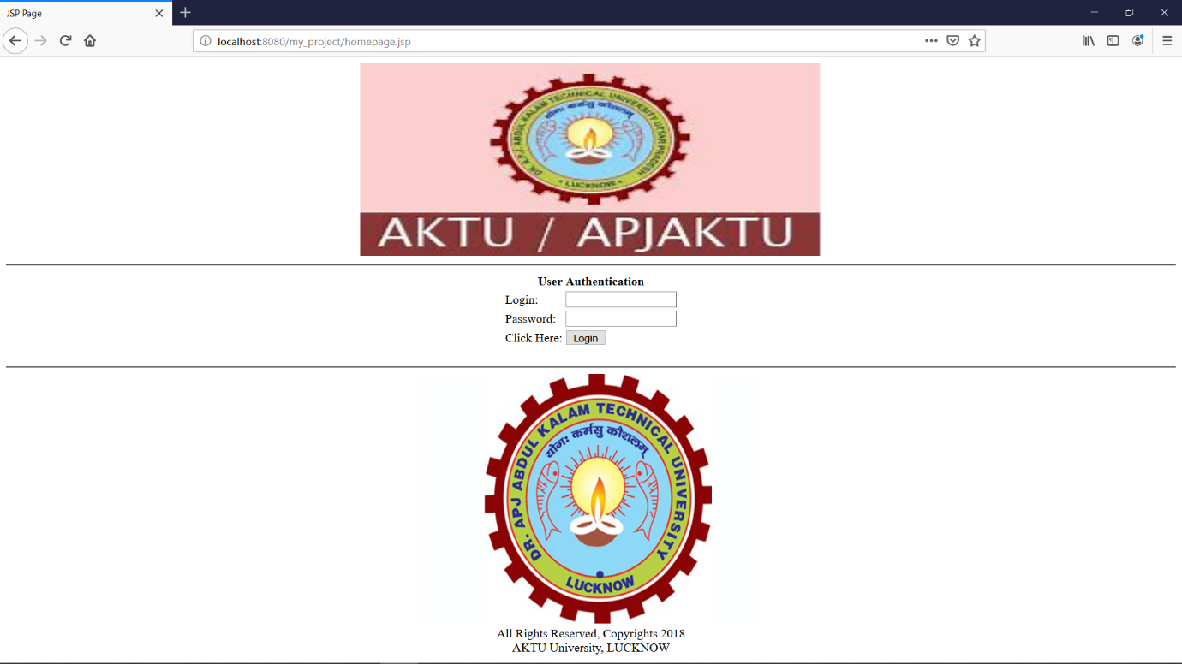

2.ADMIN LOGIN:

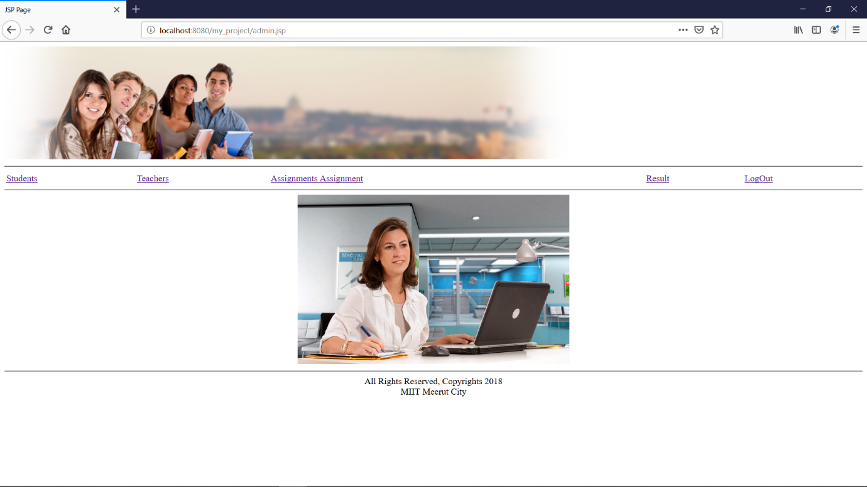

3.STUDENT ID CREATE BY ADMIN:

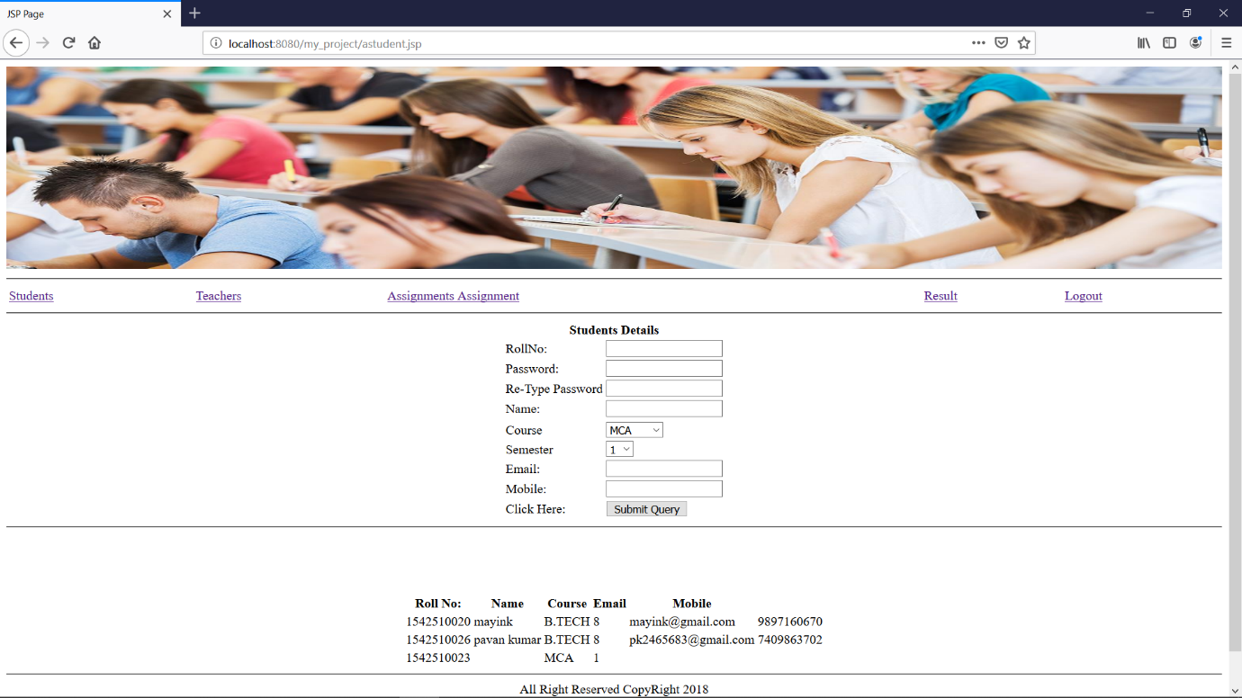

4.TEACHER ID CREATE BY ADMIN:

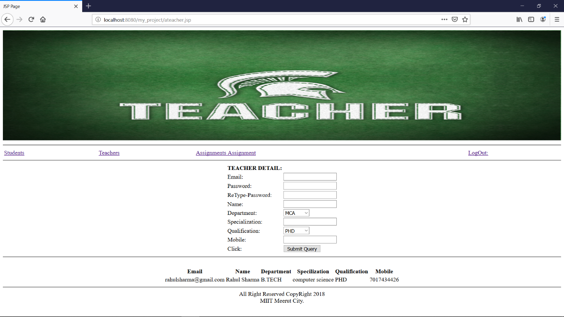

5.SHOW ASSIGNMENT LIST:

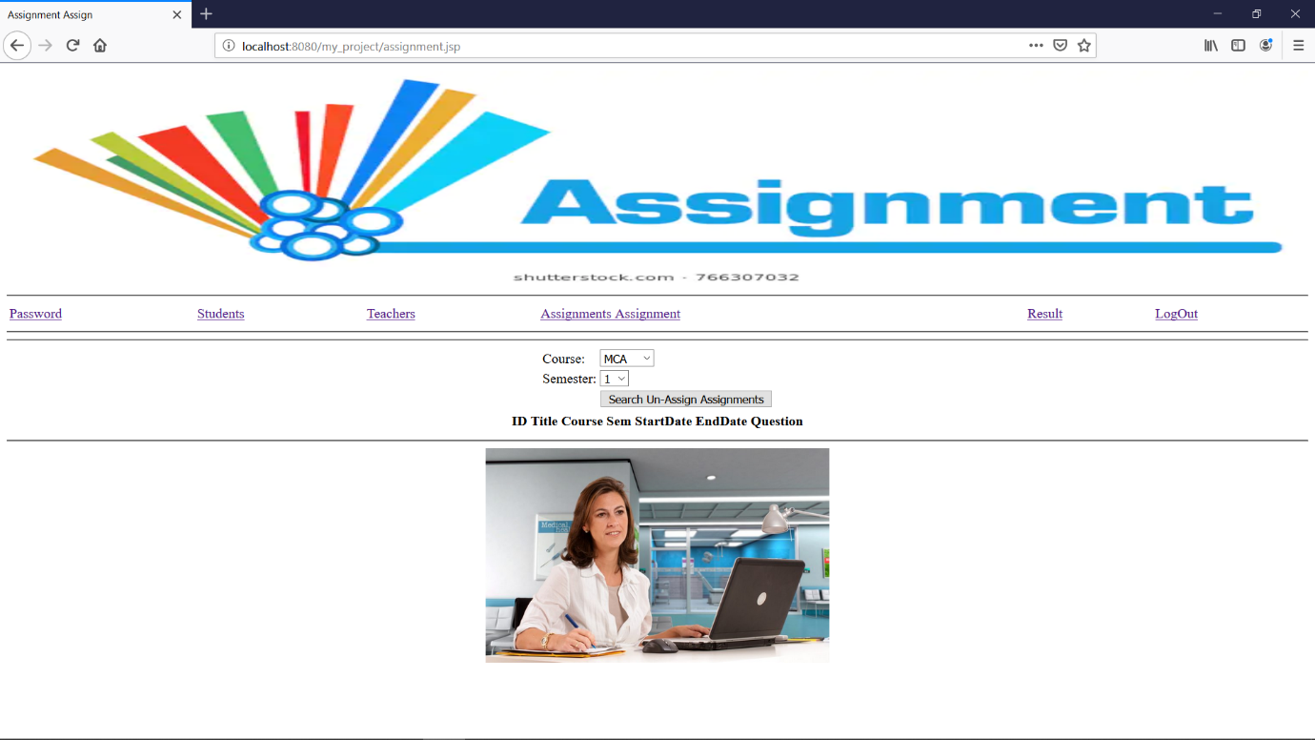

6.SHOW STUDENT MARKS LIST:

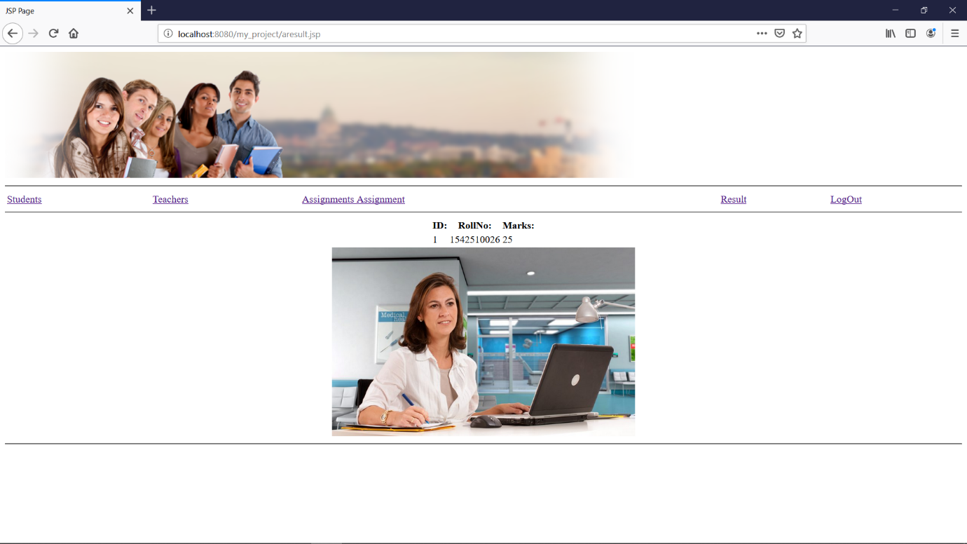

7.TEACHER HOME PAGE:

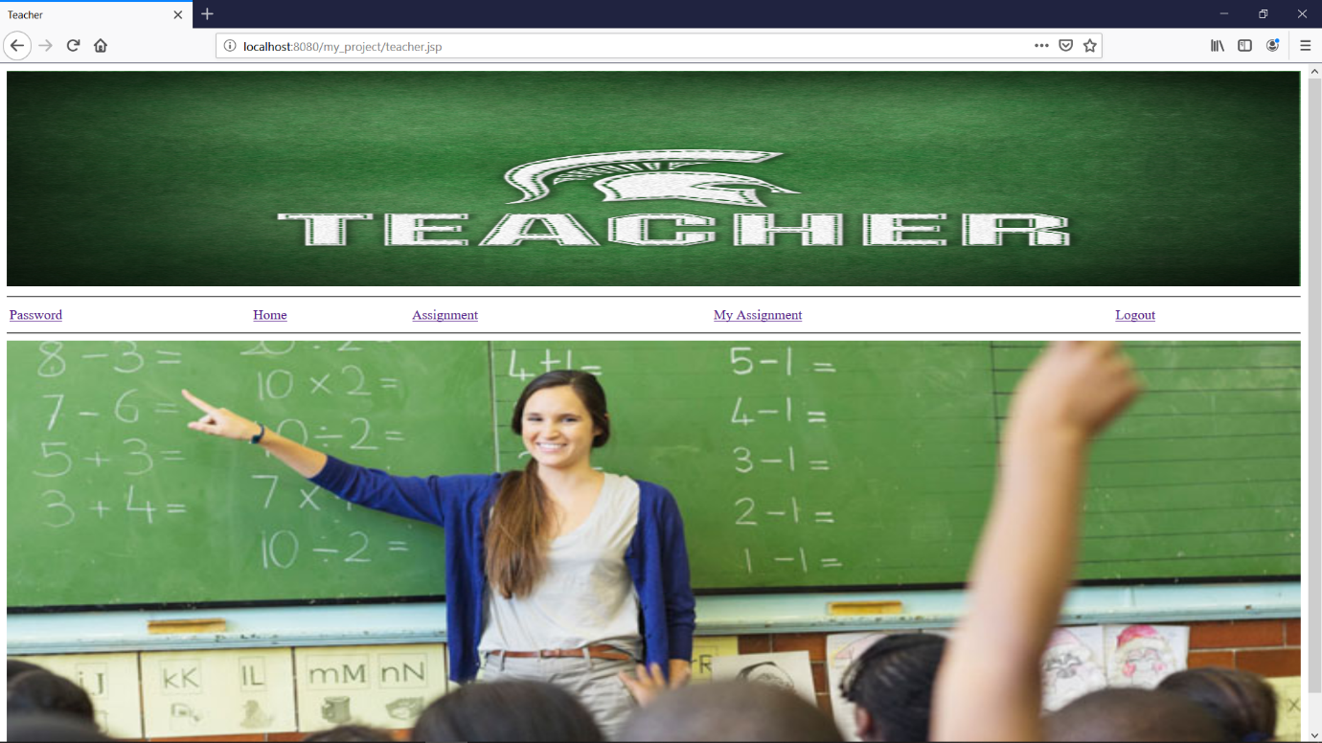

8.ASSIGN ASSIGNMENT TO STUDENT:

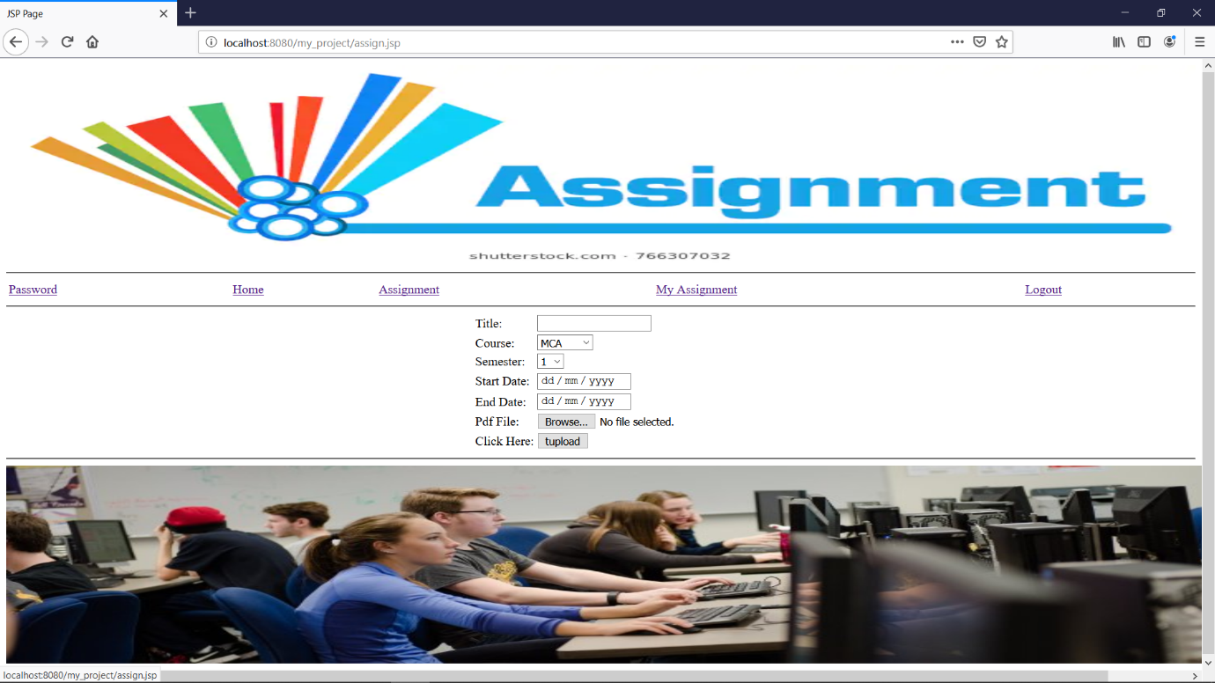

9.CHECK STUDENT’S ASSIGNMENT:

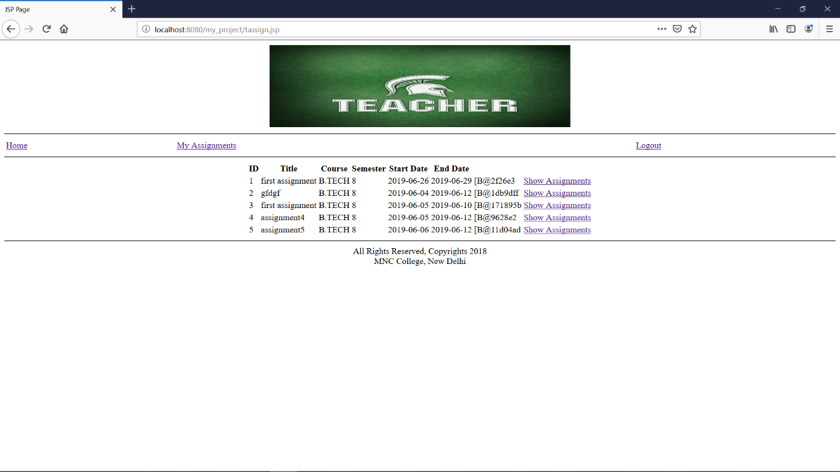

10.CHANGE OUR PASSWORD:

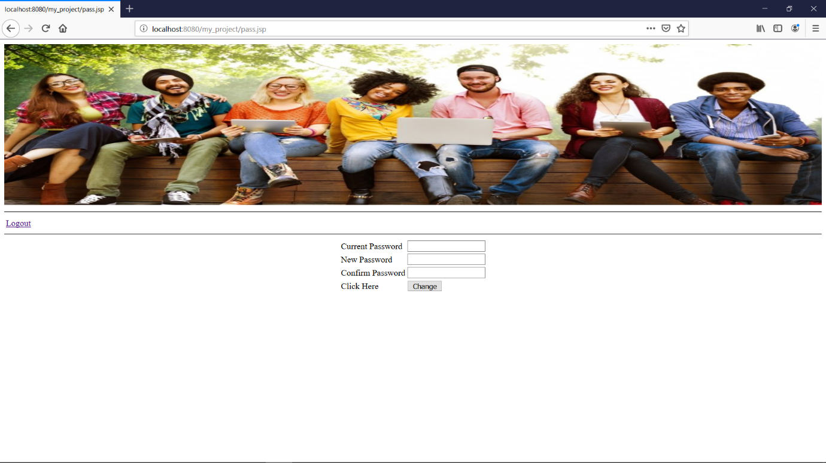

11.STUDENT HOME PAGE:

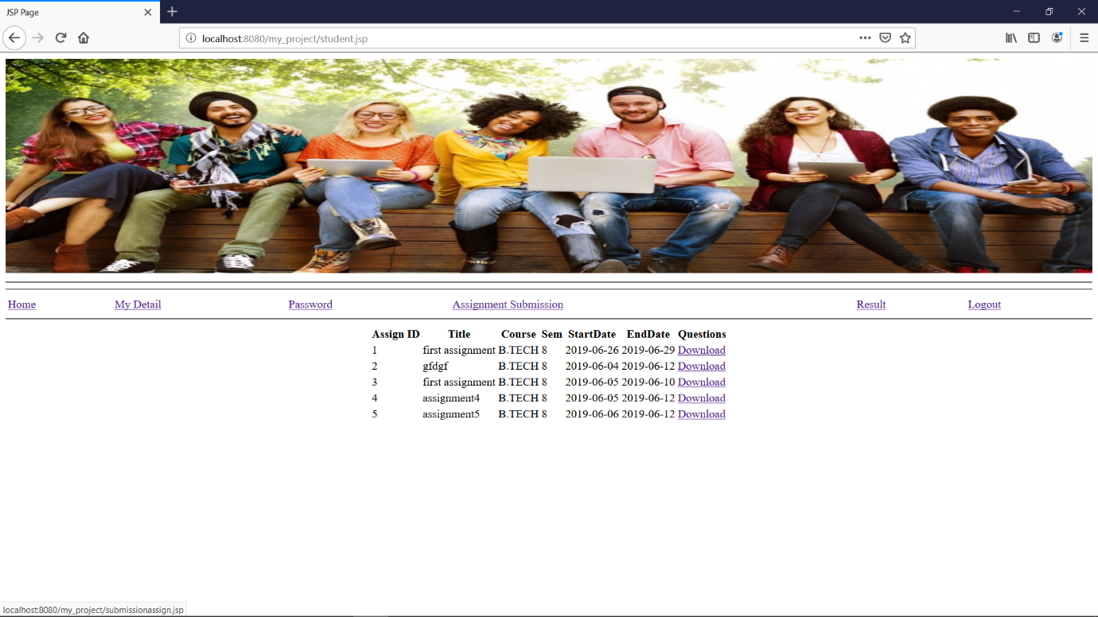

12.CHECK OUR DEYAILS:

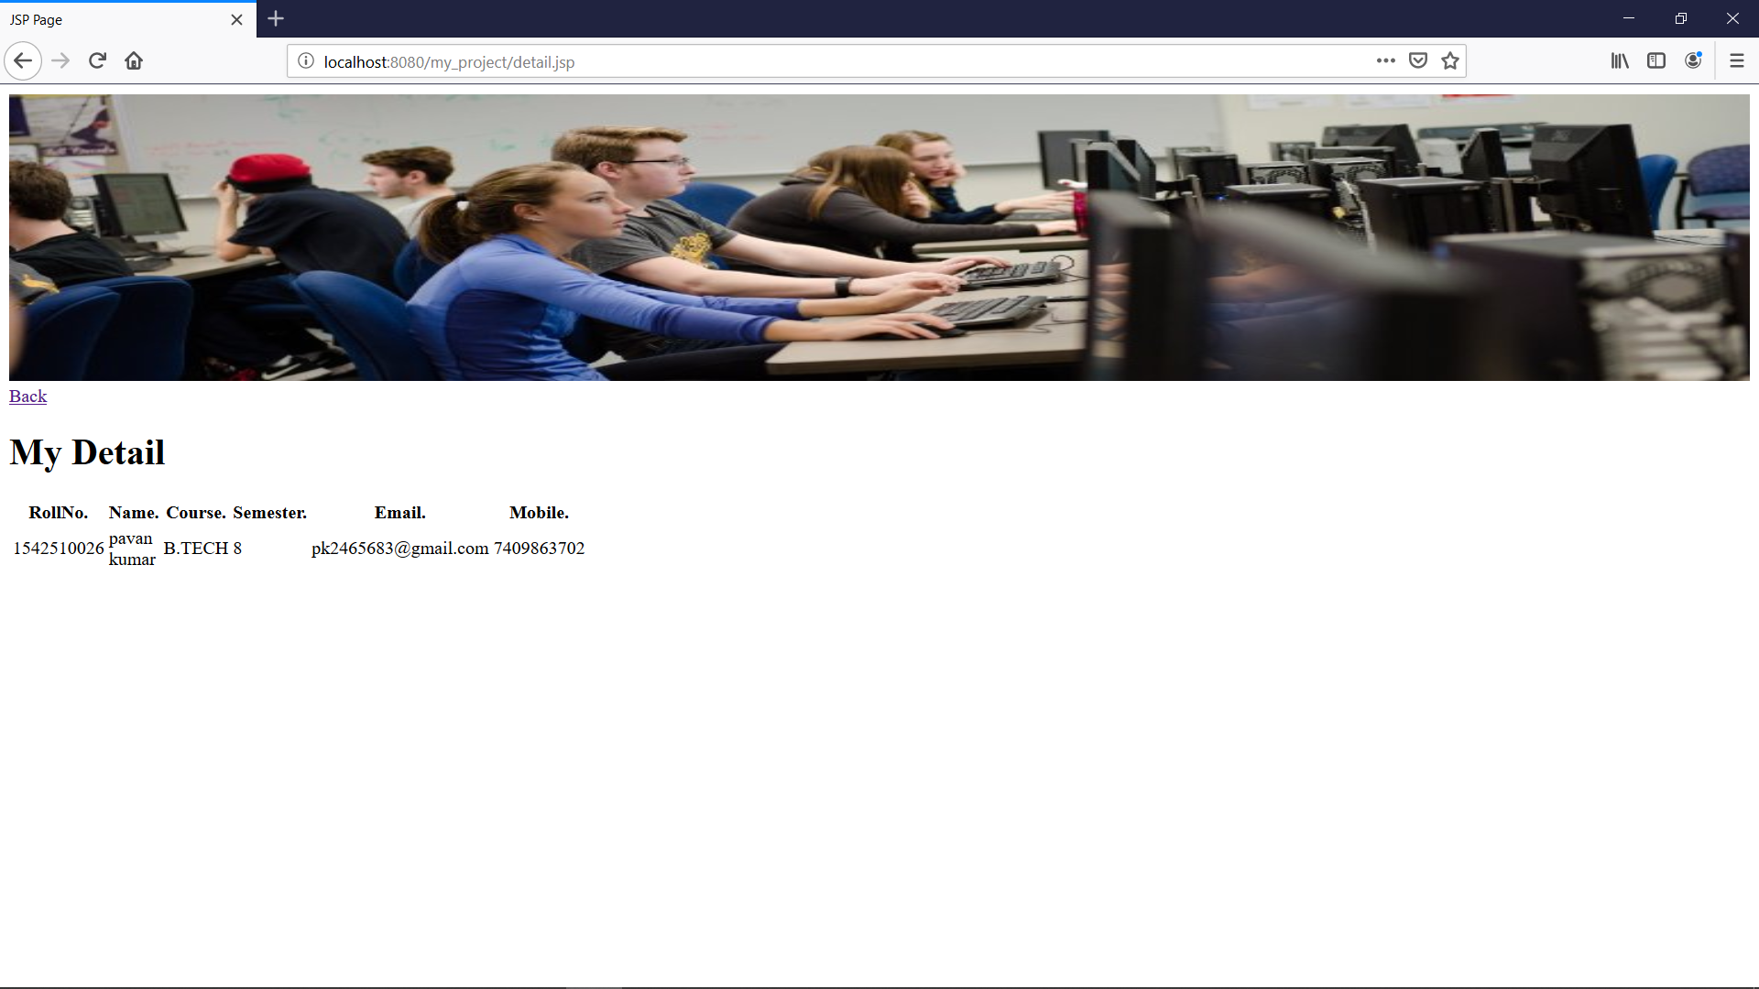

13.SUBMIT ASSIGNMENT:

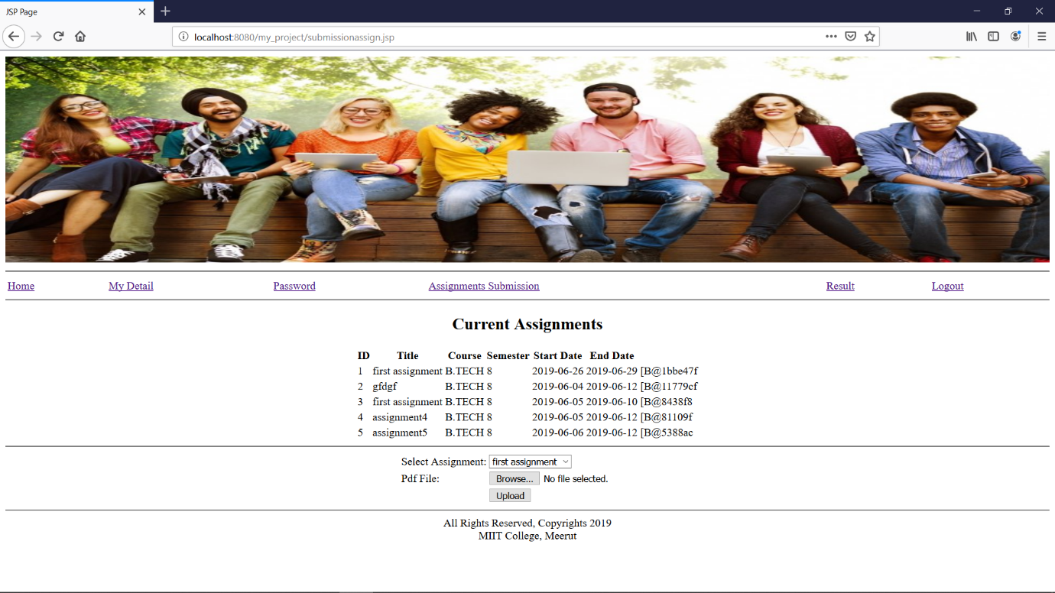

14.CHECK OUR MARKS:

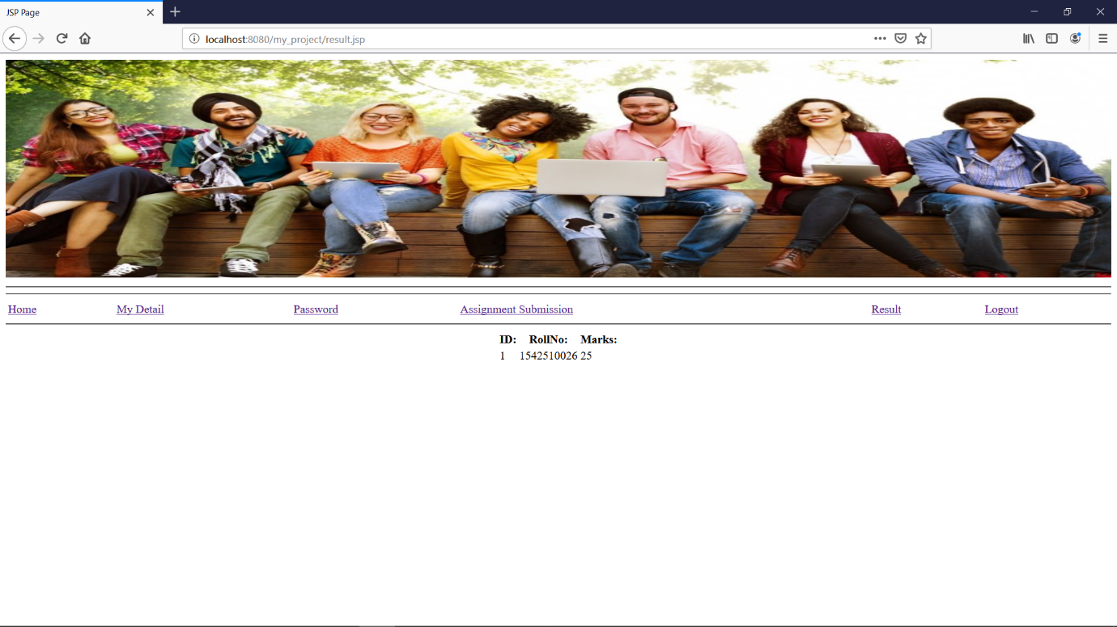

1. **System security measures**

To do an adequate job on security, a System analyst must analyze the risk, exposure, and costs and specify measures such as passwords and encryption to provide protection of software and recovery request procedures must be available when needed.

**SECURITU AGAINST UNAUTHORIZED ACCESS**

* **Use of administrator password** : The password provides security to the administrator of associates user so that unauthorized user can not access the facility of associates user.
* **User related cheeks and validation** : for this software, the developer user related checks and validations from the user.
* **User authorization keys** : Password checking for logging of users.

**SECURITY AGAINST DATALOSS:**

* **Provision of efficient data backup system:** In this software an efficient system is used for adequate backup facility.
* **Offline data storage:** This system is capable for offline data storage.
* **Multiple database backup :** The efficient system is use for this software is give multiple data backup.

**10. Future Application of the Project**

**FUTURE SCOPE OF THE APPLICATIOM:**

The Online Assignment is for the manage process can be future development into a separate, automated system with following enhancement.

* Help file can be included The system ,as of now ,does not support any help facility for the user of the system. A help menu can be provided with a special function key and help command in the main page itself. Help can be either introduced window, a reference to a printed in a fixed screen location.
* The system can use typed commands. As they were once the most common mode of communication with the system. The typed command can be provided through control sequence or function keys or typed word.
* A training module can be included in the system this module can be used to train the users of the system about the systems usage.

**11.Bibliography**

* Software Engineering, A practitioner’s Approach, **pressman McGraw Hill.**
* An Introduction to Database system by **Bipin C Desai.**
* Object Oriented modelling and Design by **James Rambagh.**
* Java complete Reference by **Patrick Naughton, Herbert Schildt.**
* JDBC Database Access with Java by **Graham Amelton.**